Community Foster Homes
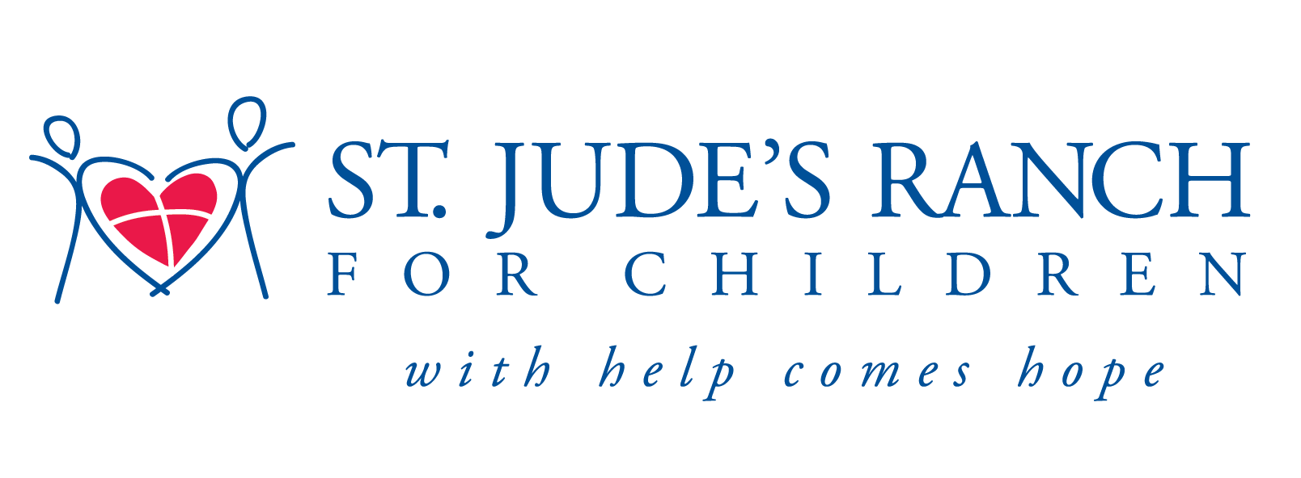
Have you ever wondered how you can help abused children?

Every day children are in need of safe, loving foster homes in the
Boulder City community and we need people like you to open your heart and home to them.
Come learn how you can become a foster parent with
St. Jude’s Ranch for Children.

June 21, 2011 5:30-6pm & June 30, 2011 6:00-7:00pm

Location: St. Jude’s Ranch-Paulson Hall (near the chapel)

For more information please contact Christina Vela~702-294-7101

