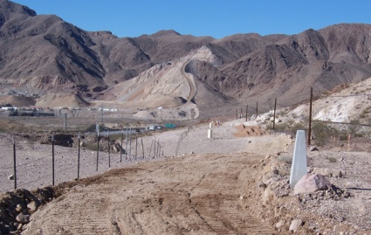
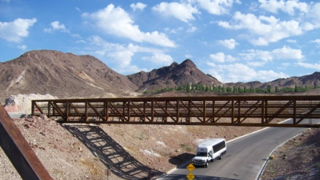
Ribbon Cutting &
“Cut and Run”
for New Trail Segment of Boulder City River Mtn Loop Trail
9:00 A.M., Saturday, October 17, 2009
Railroad Pass Casino

- A ribbon cutting for the newest segment of the River Mountains Loop Trail, connecting and running through Boulder City to the Lake Mead National Recreation Area on the east and Railroad Pass Casino on the west will be held Saturday October 17, 2009

- The ribbon-cutting event will take place at 9:00 A.M. a.m. at the Railroad Pass Casino upper parking lot near the River Mountains Loop Trail trailhead.

- Speakers will include:
- Boulder City Mayor Roger Tobler
- National Park Service Superintendent Bill Dickinson for SNPLMA
- Railroad Pass Casino, Curt Thompson, Director of Operations
- River Mountains Loop Trail Partnership Chair, John Holman

- The Nevada State Railroad Museum train will transport walkers and bikers from the Museum, 600 Yucca Street, to Railroad Pass for the ribbon cutting ceremony. After the ceremony the train will return our guests to the museum.

The train leaves the Yucca Street station promptly at 8:15 A.M.

- Funding for this trail has been made possible by the Southern Nevada Public Lands Management Act and other sources including: the Federal Highway Administration, the Nevada Department of Transportation and Boulder City.
- Information about other trails and bike paths in Boulder City will be available. The Boulder City Chamber of Commerce sponsors a 5K Run, Walk, & Bike. Registration form on the back of this flyer.
- Refreshments will be provided by the Boulder City Chamber of Commerce and BC Albertsons

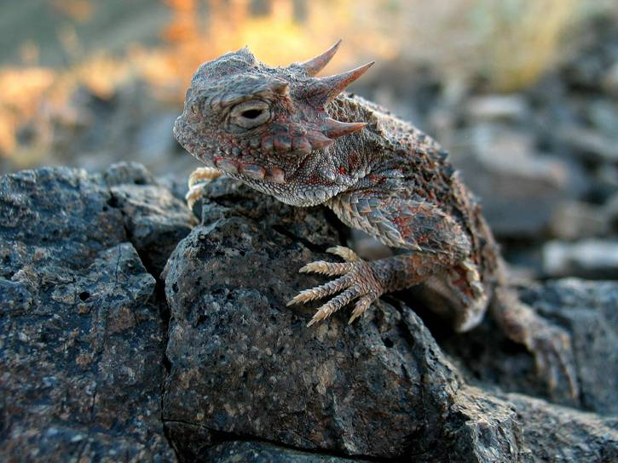
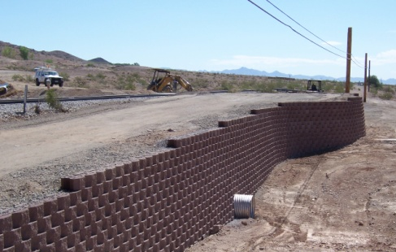
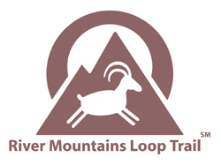

“Cut and Run”
5K Fun Run, Walk, Bike, Stroll
Immediately following the Ceremony at Railroad Pass

Sponsored by the Boulder City Chamber of Commerce
$20 registration fee (6 years and older) benefits the
Boulder City Chamber High School Scholarship Fund

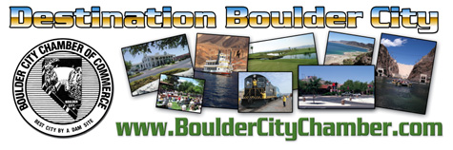

Fill out the registration form below and return it along with your $20 registration fee to the Boulder City Chamber of Commerce ~ 465 Nevada Way ~ Boulder City, NV 89005
For further information call: 293-2034 or 293-9358. Please register by Fri., Oct.9, 2009.

Name __________________________________________________________

Address ________________________________________________________

Phone ______________ Emergency Contact Name/Phone ______________

E-mail _________________________________________________________

Participation Waiver: I hereby acknowledge that I have voluntarily applied to participate in the “Cut & Run 5K”. I am aware that walking/running on a trail/road is a potentially hazardous activity, and I am voluntarily participating in this activity with knowledge of the danger involved and hereby agree to accept any and all risks of injury or death. I agree to abide by any decision of a race official relative to my ability to safely complete the run/walk. I am aware of and voluntarily assume all risks associated with running/walking including, but not limited to falls, contact with other participants, the effects of weather, including heat, humidity, extreme coldness, traffic or other conditions of the road, all such risks being known and appreciated by me. I agree that I, my heirs, distributees, guardians, legal representatives and assigns will not make acclaim against, sue, attach the property of, or prosecute the City of Boulder City, the Boulder City Chamber of Commerce or the Cut & Run Partnership including any and all affiliated individuals, or any other race sponsors and their employees for injury or damage resulting from my participation on the event. In addition, I hereby release the above companies, from actions, claims or demands that I, my heirs, distributees, guardians, legal representatives, or assigns now have or may hereafter have for injury or damage resulting from my participation in the Cut & Run. If I do not follow the rules of this event, I understand that I may be removed from this competition. I give my permission to the Boulder City Chamber of Commerce to use any photographs, videotapes and other recordings of me that are made during the course of the event. Incomplete and/or unsigned entries will not be accepted. Note: for your safety, no rollerblades, scooters or skateboards are allowed. Entry fees are non-refundable, non-transferable and non-tax deductible. I understand that, by signing in the space below, I have read and agree to the above stated terms in the Participation Waiver.

Date ________ Signed ______________________________ Print ________________________________

Signature of parent or guardian if under 18 ______________________________________________________

