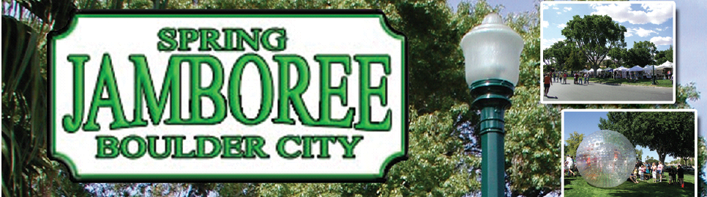
March 1, 2011

Dear Chamber Member,

The Boulder City Chamber of Commerce Spring Jamboree 2011 is right around the corner. Spring is a great time of year in Boulder City and we enjoy celebrating it with a fun, family, festival in the park. This year is the 34th Annual Spring Jamboree and we are thrilled to tell you that this year will be the largest festival we’ve ever held.

This fun filled two-day EXTRAVAGANZA brings together skilled artists, great games, fun rides, a street dance, taste tantalizing food vendors from all over the western United States and combines them with many talented entertainers from Boulder City and the Las Vegas Valley, producing a weekend of excitement and over the top family entertainment. The Pandraggers Car Club has announced that they expect over 200 cars for the annual Rod Run held in conjunction with Spring Jamboree. With such variety of attractions, we plan to entertain all ages and interests. You won’t want to miss the ever expanding antiques and collectibles area. The rides and entertainment will be top-notch and the Street Dance headliner, Strung Out Sessions, will have a great rock n’ roll flair. We will fall in love with the little people during the annual Little Miss and Mister Boulder City Pageant sponsored by Dance Etc and the Bark In The Park dog show sponsored by See Spot Run and BC Real Estate. The 3-on-3 Basketball tournament will again stir up good sportsmanship in the Rec. Center benefiting the Boulder City High School basketball teams, and the Third Annual Nikki Anderson-Mangin 5 K Run and 1 Mile Walk will again depart the event grounds early Saturday morning.

I am writing in solicitation of donations for sponsorships that will enable the Boulder City Chamber of Commerce to provide a phenomenal family oriented community event. Sponsorship money is applied directly to advertising to the Las Vegas Valley and surrounding areas, attracting the nearly 30,000 guests that attend our event each year. The packages are showcased in the enclosed letter. We hope you’ll find interest in assisting us with these amounts, but if you find that another amount would be more suitable, we’d love to discuss that with you to create a custom package for your corporation.

I would like to thank you in advance for considering this great opportunity to highlight your business during this fundraising event. We appreciate you taking the time out of your schedule to help us realize our dream of a fun, safe, family driven community event.

If you would like to schedule a formal meeting to further discuss the organization and this year’s exciting event, please contact me at the Chamber office at 702-293-2034. To view the current Spring Jamboree website go to www.springjamboree.com, or check out the Spring Jam video at www.bouldercitychamber.com to view a video of last year’s event. Thank you again for your consideration.

Sincerely,

Jill Rowland-Lagan,
CEO, Boulder City Chamber of Commerce

This Fundraiser is Presented By
The Boulder City Chamber of Commerce

Sponsorship Packages

Title Sponsor Package - $5,000

- Prominent logo placement on big screen of the main stage during evening festivities.
- 15 minutes on main stage presentation of company information, promotions, giveaways, etc. by company representative each day. Time can be divided up each day.
- Booth location reserved at main stage.
- Company name as Title Sponsor on event material and media releases.
- Company representative to do BCTV interview with Spring Jam Director prior to event.
- Web site link included on all web pages set for this event.
- Listed as Sponsor with company name and logo displayed on www.springjamboree.com
- Company Banner prominently displayed on main stage.
- Sponsor promotional items and information in gift bags to Artists, V.I.P.’s, & entertainers.
- Photo opportunities with Sponsor Officials, Event Chair, Dignitaries, etc.
- Sponsor tag mention in media interviews.

Gold Sponsor Package - $3,000

- 10 minutes on main stage presentation of company information, promotions, giveaways, etc. by company representative each day.
- Booth space reserved near main stage.
- Company name as Sponsor on event material and media releases.
- Web site link included on all web pages set for this event.
- Listed as Sponsor with company name and logo displayed on www.springjamboree.com
- Photo opportunities with Sponsor Officials, Event Chair, Celebrities, etc.
- Sponsor promotional items and information in gift bags to Artists, V.I.P.’s, & entertainers.
- Sponsor tag mention in media interviews.

Silver Sponsor Package - $1,000

- 5 minutes main stage presentation of company information, promotions, giveaways, etc. by company representative each day.
- Booth space reserved in entertainment park area.
- Company name as Sponsor on event material and media releases.
- Web site link included on all web pages set for this event.
- Listed as Sponsor with company name and logo displayed on www.springjamboree.com
- Photo opportunities with Sponsor Officials, Event Chair, Celebrities, etc.
- 1 sponsor promotional item and information in gift bags to Artists, V.I.P.’s, & entertainers.
- Sponsor tag mention in media interviews.


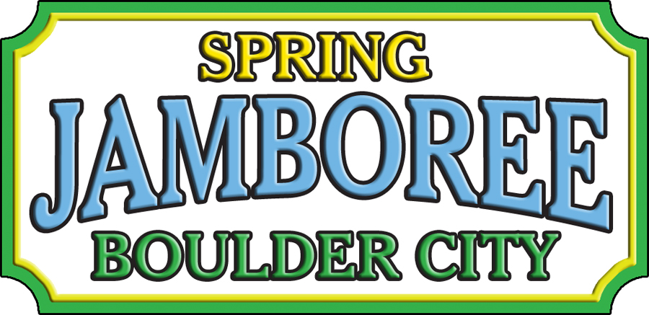
Spring Jam Entertainment is always a highlight of this fun-filled, family festival. Take advantage of the large crowd that gathers around Center Stage by advertising during one of our many commercial breaks. As stage crews change out equipment between performers, you’ll have 5 minutes to come front and center to promote your business. Tell us about what your company offers, sells, or something new that we won’t want to miss and why we should stop by and visit. This is also a great time for organizations with upcoming events to promote their date and encourage guests to return to BC for another amazing experience.

Commercials are just $25 each and will be scheduled on a first-come, first-served basis. Time slots will be discussed upon payment.

During the always well attended Street Dance on Saturday night, you’ll also have the opportunity to have your logo on the big screen next to Center Stage. It will flash throughout the evening, once the sun sets. This inexpensive way to brand your name and logo is only $50 for multiple views.

If you’d like to participate in either advertising program, please contact the Chamber at 293-2034 to reserve you spot today.

5 Minute Commercial Break ~ $25 each Logo Flash on Big Screen ~ $50

Center Stage
Advertising Opportunities

