

***For Immediate Release                                                          Thursday, February 25, 2010***

**CONTACT:** Jon Summers / Tom Brede, (202) 224-9521

**REID MEETS WITH RAILROAD INDUSTRY TO DISCUS TRACK MAINTENANCE TAX INCENTIVE**

*Short Line Railroad Tax Credit offsets upgrades critical railroad infrastructure and creates jobs for Nevadans*

**Washington D.C**.—Nevada Senator Harry Reid welcomed members of the rail industry today to discuss legislation that will extend a crucial tax credit, creating jobs for Nevadans and rebuilding railroad infrastructure. The tax credit ensures the maintenance of short rail lines that serve Nevada communities. The Boulder City Chamber of Commerce also participated in the meeting.

Reid expects the track work supported by this tax credit to create nearly 700 million worker hours a year, countering 2010 lay-offs due to the expiration of the tax credit.

“I am devoted to creating jobs for hard working Nevadan families,” said Reid. “This tax credit opens new avenues that will create jobs, increase commerce and diversify the economy of Nevada communities.”

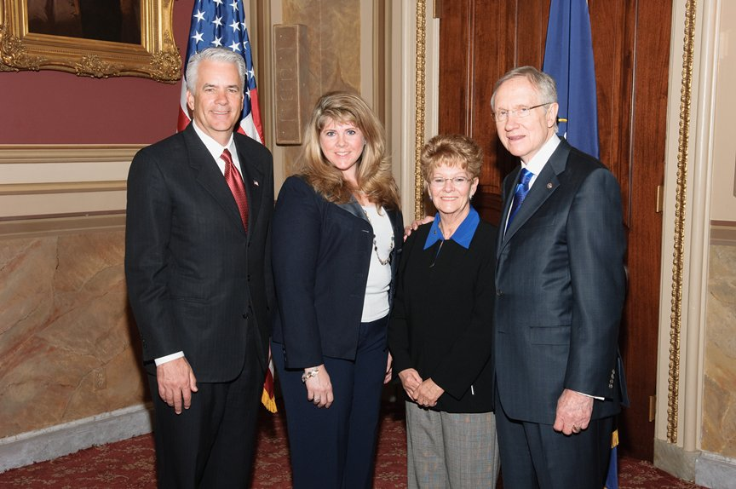

Reid meets with members of the rail industry to discuss extending Short Line Railroad Tax Credit that will help create more jobs for Nevadans and ensure proper track maintenance.

###