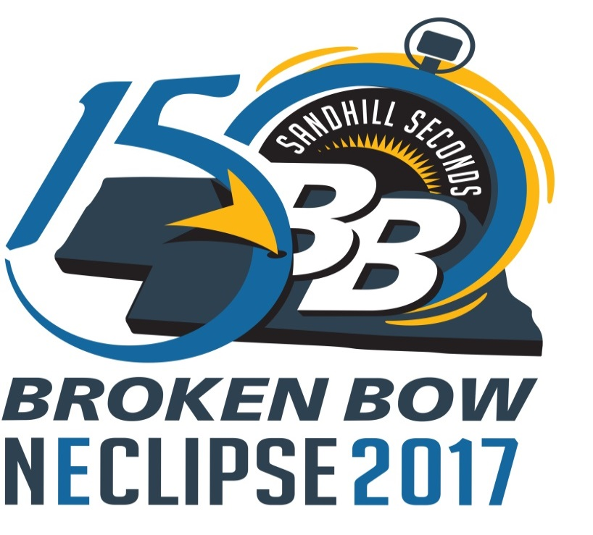
Friday – August 18, 2017
All day – 9-Hole Grass Greens at the
Broken Bow Country Club
August 18 – 20 Cornhusker Futurity Barrel Racing
Custer County Fairgrounds Indoor Arena

Saturday – August 19, 2017
7:00 am – TEAMMATES 5K Walk/Run
Check-In, Downtown Square
8:00 am – TEAMMATES 5K Race begins on
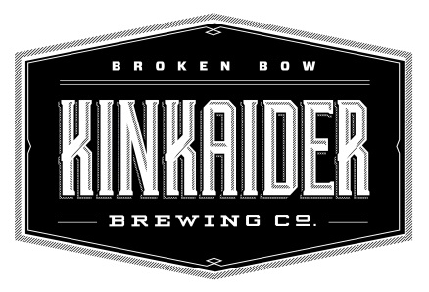
9th Street in front of the Arrow Hotel
Craft Vendors in the Square
starting at 10 a.m.
Black out specials offered by our local businesses!!!

11:00 am – Cook-Off and Kinkaider Beer at Melham Park
Cooker entry fee $50 (people’s choice cash prize for the winner) All you can eat entry fee $10
Noon-6 pm – Cool off at Broken Bow’s Aquatic Center
1:00 pm – Tank Races in the Melham pond (Dress up as your favorite farm animal)
Adults teams of 4 entry fee $100, High School teams of 4 entry fee $80
(Tanks provided) Kayak Races: All ages individuals entry fee $25
Cash prizes for the winners and best dressed team
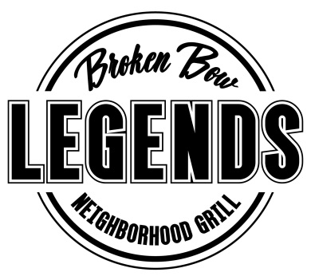
8:00 pm to Midnight – Street Dance at Legends Neighborhood Bar and
Grill with music by “The James Lee Band”
Based in the Sandhills Nebraska, the JLB is dedicated to playin'
the country tunes you need to get your party on.”
No cover charge – the community is invited to set up
chairs in the square

Sunday - August 20, 2017
Guided Pasture Tours at Straight Arrow Bison Ranch (available Sunday and Monday)
Call 308-872-3066 for reservations

Broken Bow Chamber 150 Drive – this is a perfect time to participate in the Broken Bow Chamber’s
150 Drive - log on at www.brokenbow-ne.com for details and to register

Sunday, August 20, 2017 continues
1:00 pm – Introduction to Pioneer Photographer Solomon Butcher and discussion at the Custer
County Historical Society located on the west side of the square in Broken Bow.

7:00 pm - Cowboy Church at the Custer County Fairgrounds – please bring camp chairs
Dusk - Outdoor movies at the Custer County Fairgrounds (sunset is set for 8:30 pm)
The following movies will start shortly thereafter: “Through My Eyes”
“Solomon Butcher, Frontier Photographer” – produced by PBS (through NET)
“The Beef State” – produced by John Carter
Food and Beverages will be available for sale at the Fairgrounds

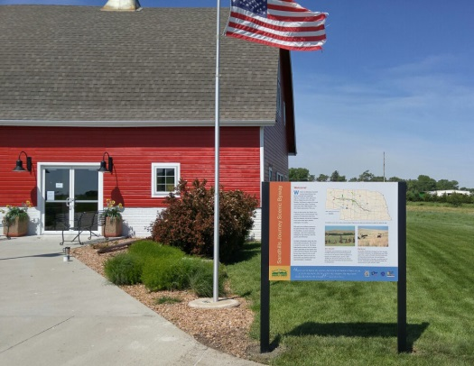
Monday, August 21, 2017
Events take place at the Sandhills Journey Scenic Byways
Interpretive Center on the east side of Broken Bow (The Barn)
8:00 am – The grounds at The Barn open – Viewing and Events at the
are Free; however there will be a nominal fee for parking. Parking is
available at Plains Equipment and/or across State Highway 2 at the
Custer County Fairgrounds – Transportation provided to The Barn.
Please bring your own chairs – some picnic tables will be provided
but will be first come, first served.

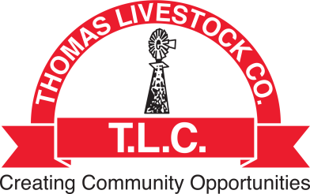
10:00 am – Noon– FREE Bacon-Wrapped Pork K-Bobs courtesy of Thomas Livestock Company & the Nebraska Pork Producers

9:00-2:00 pm – Additional snacks, food, drink, craft items will be
for sale in the parking lot of The Barn
(No parking available in the lot next to The Barn.)

9:00 am – Music Performance by “We’re Not Twins”
10:00 am – R.P. Smith Cowboy Poet (Like what you hear - RP will have his CDs for sale inside the Barn)
10:30 am – “The Math of it All” – Stephanie McCaslin PHD - Outdoor venue – safety briefing

11:30-1:30 pm – ECLIPSE VIEWING: The Eclipse starts at 11:32 am; totality starts 12:55 pm
Check out the chicken coop, Watch the activity; Visit the vendors, Take a tour of the barn,
Check out the antique farm equipment on display; Enjoy the excitement with your friends.

1:30 pm – NE150 DRIVE WINNER DRAWING!!
1:30 pm – Music Performance by We’re Not Twins Continues (CDs for sale inside the Barn)
2 pm – “The Math of it All” by Stephanie McCaslin PHD - Indoor venue inside the Barn

Monday afternoon activities continue at the following venues:
Legends – Bonfire Grill – Kinkaiders Brewery

