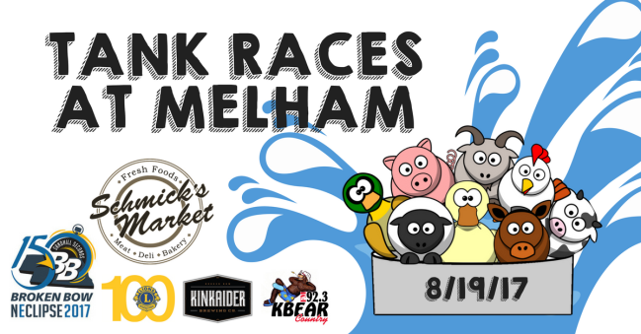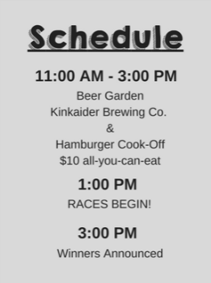

NEclipse 2017 Battle of the Burgers at Melham
Saturday, August 19, 2017

This is a non-sanctioned event so it's open to EVERYONE, rookie/experienced teams.

Broken Bow NEclipse 2017 is pleased to host the NEclipse 2017 Battle of the Burgers at Melham. The event will take place Saturday, August 19th, from 11:00 AM – 3:00 PM, at Melham Park in Broken Bow, NE.

Individuals, teams, community organizations, chefs, and businesses are encouraged to participate in this event. We ask that each team submit a Team Entry Fee of $50 to secure your space in the NEclipse 2017 Battle of the Burgers. Cook-off spots are limited, so register today! All teams must cook a minimum of 20 pounds of meat.

We invite each team to bring their best burger to this competition. The burger style is completely up to you and your teammates – get creative! Teams will have two opportunities to win.
*Burger & Side Dish
- Attendees will be given a chance to vote for the People’s Choice Best Burger and Best Side Champion.
-Both champions will receive a cash prize. The awards ceremony will take place at 3:00 p.m.

Necessary Supplies: - Your own cooking station, grill, and a meat thermometer
- All food products needed to cook your burgers
- Any special product you would like to use in, or on your burgers
- All food products needed to cook your side dish

We supply: - Ground beef (sponsored by Schmick’s Market), buns, condiments, napkins, plates and utensils

- - - - - - - - - - - - - - - - - - - - - - - - - - - - - - - - - - - - - - - - - - - - - - - - - - - - - - - - - - - - - - - - - - - - - - - - - - - - - - - - - - - - - - - - - - - -

Griller or Team Name:__________________________________________ Phone #______________________________
Address:___________________________________________________________________________________________
City:_____________________________________________ State:________ Zip Code:_____________________
Email:_____________________________________________________________________________________________

If competing as a Team, list each member:
1._________________________________________ 2.____________________________________________
3._________________________________________ 4.____________________________________________

Rules: All entries must be cooked on the designated Melham grounds. Side dish entries must be grilled or cooked on site as well. ALL SIDE DISHES MUST BE COOKED ON THE GRILL. For safety reasons, we will NOT accept cold salad side dishes requiring refrigeration. Cooking can be done on a charcoal, wood, propane fired device, or electric roaster/cookers. The BBQ Contestant is responsible for observing accepted and prudent temperature and sanitary requirements. No refund of the Team Donation will be made once the applicant has been accepted into this contest. I agree to abide by the rules, regulations and decisions of NEclipse 2017 Battle of the Burgers at Melham.

By signing below, you are stating that you understand and will abide by the rules above and that your team is committing to attend the burger cook-off at Melham Park in Broken Bow, NE on Saturday, August 19, 2017.

Signature: _____________________________________________________ Date: ________________________

RELEASE AND WAIVER OF LIABILITY
It is my wish to participate in the NEclipse 2017 Battle of the Burgers at Melham August 19, 2017, in Broken Bow, Nebraska. I understand, appreciate, and acknowledge that property damage and injuries are common to such events. I fully assume the risk of such property damage and injuries, and I participate in this voluntarily and with my full knowledge of the inherent risks.

I hereby waive and release any and all rights either my heirs successors and assign or I may have against City of Broken Bow and the Broken Bow Lions Club, arising from my participation in this event, including but not limited to property damage and injuries. I further agree to indemnify and hold harmless all of the foregoing from any claim that may be made by me or on behalf by other third parties that might be made against me by others, arising from my participation in the foregoing event.

This waiver shall remain valid and my not be unilaterally rescinded by the participant. This form is to be signed by participant or if participant is less than 18 years of age to be signed by the parent or legally responsible guardian.

In addition to the release and waiver of liability, signing this form acknowledges that you have read and fully understand the Battle of the Burgers Rules. Also, by signing, I give permission for my or my child’s name and image to be used to advertise this event and to announce the winners of this competition in the local newspaper, social media, and websites pertaining to this event and its organizations.

Signature_____________________________________________ Date: ________________________________

Signature_____________________________________________ Date: ________________________________

Signature_____________________________________________ Date: ________________________________

Signature_____________________________________________ Date: ________________________________

This form MUST BE signed and returned with your application and entry fee.
For more information visit us on Facebook.

Checks payable to: Custer Economic Development Corporation (CEDC)
Registration & checks can be dropped off at any of these locations:

Universal Insurance Bruning Bank Custer County Chief Chamber Foundation
Stephanie Evans Kim Schipporeit Mona Weatherly Hannah Hundley
940 S E St 803 S D St 305 S 10th Ave 424 S 8th Ave Suite #4 403 S 9th Ave
308-872-6438 308-872-2757 308-872-2471 308-872-5691 308-872-2232

