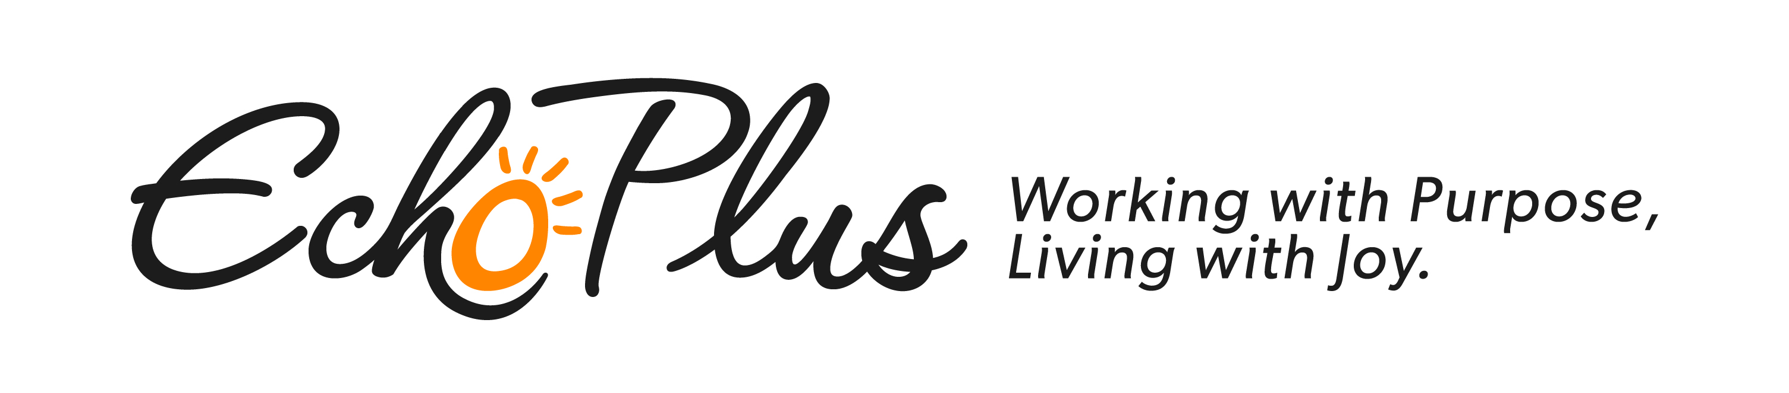
BUSINESS AFTER 5

JOIN US AT ECHO PLUS
Tuesday, November 12th

We are located at 1520 6th Avenue N.

Enjoy appetizers and adult refreshments.

We will be giving tours of our Work Activity Center
and giving updates about new contracts and services.

We look forward to seeing you!
Amanda Brewer, Executive Director

