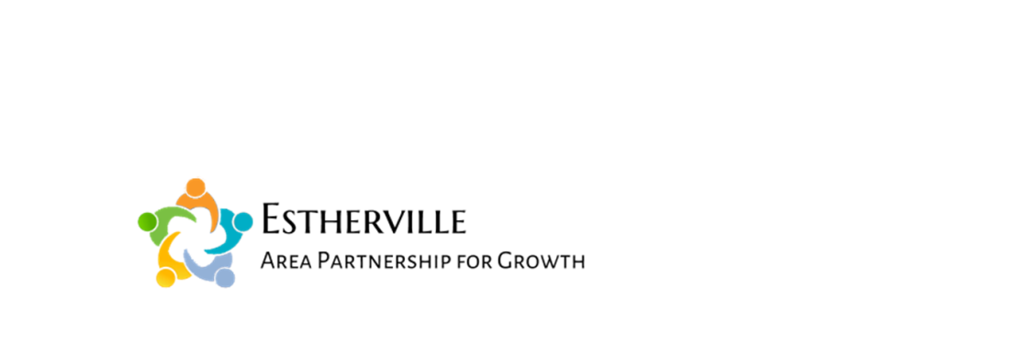
2017
Emmet County “Grow With Us” Campaign
Local Small Business Development Fund

The Emmet County “Grow With Us” development fund can provide a forgivable loan to help existing small businesses in Emmet County that have expansion plans which can be completed within 1 year. The goal of the development fund is to help eligible small businesses grow their business which in turn helps grow the economy in Emmet County.
There is $25,000 available in the fund. Awards to eligible businesses can be up to $5,000 per business. The forgivable loan can be no more than 50% of the total cost of the proposed project.
Application Criteria:
- Must be an existing locally-owned small business in Emmet County.
- Applicants must have no more than 25 FTE employees and annual sales of less than $1,000,000.
- Must be a “for-profit” business.
- Must be a full time business that has been open for at least one year in Emmet County.
- A completed application must be submitted by the end of the business day on Tuesday, August 15, 2017. Applications submitted after the deadline will not be considered.
- An incomplete application will be returned to be completed.
- No equipment or products can be ordered or the project started prior to being awarded a forgivable loan.
- Last year’s grant recipients are not eligible this year.
What’s Eligible?
- The addition of a new product line or service.
- Purchase new equipment or fixtures (HVAC, plumbing not eligible).
- Interior store remodeling.
- A building expansion or relocation (it cannot be used to match Excel’s façade grant program or any other local incentive program).
- Other projects as approved by the committee.
The review committee will consider but not be limited to the following items:
- Determine if the applicant meets the application criteria with one or more of the eligible items.
- Strive to help as many eligible small businesses as possible.
- The number of years you have been in business. It must be greater than one year.
- What needs does your project meet in Emmet County.
- The ratio of the forgivable loan being requested to the total project cost.
The review committee will strive to commit available funds within 30-days of the deadline to apply. Once approved, a development agreement must be signed by the applicant and the county.

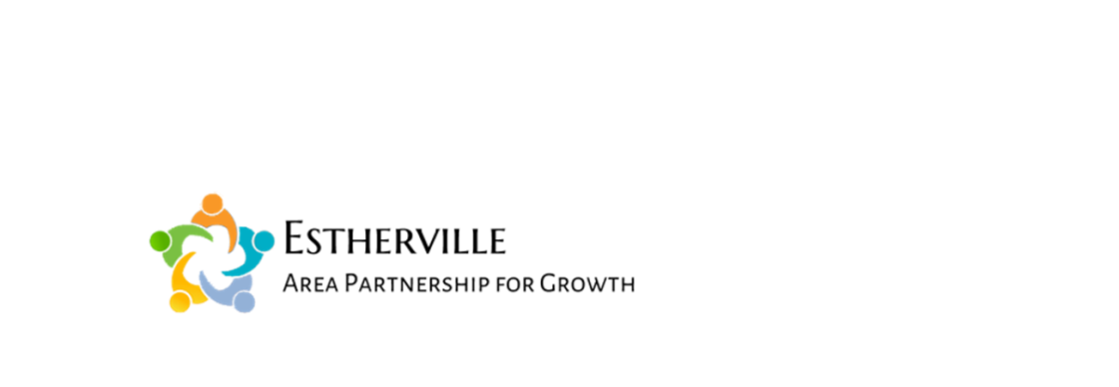
Application Form
Emmet County “Grow With Us” Campaign
Local Small Business Development Fund

Business Name
Owner Name
Business Address
Contact Information
Business Phone
Owner Cell Phone
Email Address
Project Information
Total Project Cost
Forgivable loan amount being requested
Describe your proposed project:

What else should we know about you to help the committee make a good decision:

By signing this application, the applicant acknowledges he/she had read and agrees to the program details in this application and the attached development agreement. If the improvement project is not completed as proposed or completed within the 1 year time frame, the review committee could require part or the entire forgivable loan be paid back as outlined in the development agreement.

Date

Signature

Print Name

TO BE SIGNED AFTER AN AWARD HAS BEEN APPROVED

2017 Development Agreement
Emmet County Grow With Us Program
This agreement is entered into between the Emmet County Board of Supervisors (the “County”) and ___________________________________________________ (the “Company”) as of the ____day of __________, 2017.
WHEREAS, the County desires to provide economic development assistance to locally-owned small businesses that are located in Estherville and Emmet County; and
WHEREAS, the company requests economic development assistance to complete a new project in their business as described in their Grow With Us application; and
WHEREAS, the County has established the Emmet County Grow With Us program to provide financial assistance to those companies who completed the program’s application and which were selected by the Grow With Us Review Committee to receive funding; and
WHEREAS, the County’s financial assistance will be in the form of a forgivable loan; and
NOW THEREFORE, the parties agree as follows:
- Company Requirements
- The company agrees to complete its project as described in its application.
- If the Company completes its project as described and within the 12 month project time frame, the loan will be forgiven.
- The company agrees that it will pay back part or the entire forgivable loan if any changes to the project are made, or the project is dropped, not completed or not completed within 12-months of the approval of its application. The amount to be paid back will be determined by the Grow With Us Review Committee.
- The company agrees to participate in any efforts to publicize the Grow With Us program and the companies receiving financial assistance.

- County Requirements
- The County agrees to provide a forgivable loan of $_____________ to the company at the beginning of the company’s project. The 12-month project time line ends on __________________________ .
The company’s application is attached and is part of this agreement. The County and the Company have signed this Development Agreement on the date written above.
Signed By: _______________________________ _______________________________________ Emmet County, Iowa Company Signature

