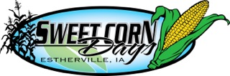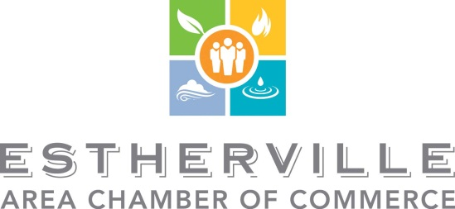

May 2015

Eighteen years ago, a few Estherville community members got together with a plan to have some fun, give away some good sweet corn, and bring visitors into our community. Since then, the Sweet Corn Days festival has grown into a four-day event that attracts thousands. People come from near and far to have fun and some even plan family or class reunions around the activities. It is truly a point of pride for our community!
Of course, the saying around here is “Free sweet corn isn’t really free”. Thanks to sponsorship from our local businesses and organizations, we have been able to put together programs that entertain young and old alike, including the family picnic, movie night, fireworks, Little Miss and Mister Sweet Corn, parade, free sweet corn, inflatable rides, and entertainers like Mr. Twister and a live band. Your sponsorship really does help make all this possible. And the attendees know it!
We do our best to recognize sponsors at the activities, through the programs and on flyers and signs on display during the event. Your sponsorship shows your investment in this community, and helps create a wonderful summer event.
The next Sweet Corn Days will be held July 30 - August 2, 2015. Please consider being a sponsor this year. All details about the different levels of sponsorship are on the following pages. Please fax your form to 712 362 7742 or call the Chamber at 712 362 3541 with any questions!
Your support is truly appreciated by the community. Thanks so much for all you do!

Estherville Sweet Corn Days Committee
Estherville Area Chamber of Commerce

Please indicate which amount and level of sponsorship you are willing to commit to for the 2014 Sweet Corn Days:
Diamond Sponsor ($2500 and above) Amount of Sponsorship____________
Diamond Sponsors will receive:
1. Photo and newspaper article recognizing sponsorship
2. Major event sponsorship and recognition
3. Business name/logo on back of staff shirts
4. Business name on corn man displayed along Central Avenue
5. You can provide the committee with a business banner to be displayed downtown during the festival
6. Business name and logo on Sweet Corn Days posters
7. Business name and logo on the Sweet Corn Days program
8. Business name/logo and website link on Sweet Corn Days Website
9. Business name/logo on Estherville.org home page for week of festival
10. 6 tickets to the Sweet Corn Days Street Dance – with new live band!
11. Recognition in a thank you advertisement
12. Preferred placement as a parade entry
Titanium Sponsor ($1750-$2499) Amount of Sponsorship____________
Titanium Sponsors will receive:
1. Major event sponsorship and recognition
2. Business name/logo on back of staff shirts
3. Business name on corn man displayed along Central Avenue
4. You can provide the committee with a business banner to be displayed downtown during the festival
5. Business name and logo on Sweet Corn Days posters
6. Business name and logo on the Sweet Corn Days program
7. Business name/logo and website link on Sweet Corn Days Website
8. Business name/logo on Estherville.org home page for week of festival
9. 6 tickets to the Sweet Corn Days Street Dance- with new live band!
10. Recognition in a thank you advertisement
11. Preferred placement as a parade entry
Platinum Sponsor ($750-$1749) Amount of sponsorship ____________
Platinum Sponsors will receive:
1. Business name/logo on back of staff shirts
2. Business name on corn man displayed along Central Avenue.
3. You can provide the committee with a business banner to be displayed downtown during the festival.
4. Your business name and logo on Sweet Corn Days posters.
5. Your business name and logo on the Sweet Corn Days program.
6. Business name/logo and website link on Sweet Corn Days website
7. 6 tickets to the Sweet Corn Days Street Dance – with new live band!
8. Recognition in a thank you advertisement
9. Preferred placement as a parade entry
Gold Sponsor ($500-$749) Amount of sponsorship ________________
Gold Sponsors will receive:
1. You can provide the committee with a business banner to be displayed downtown during the festival.
2. Your business name on Sweet Corn Days posters.
3. Your business name and logo on the Sweet Corn Days program.
4. 4 tickets to the Sweet Corn Days Street Dance – with new live band!
5. Business name/logo and website link on Sweet Corn Days website
6. Recognition in a thank you advertisement
7. Preferred placement as a parade entry

Silver Sponsor ($300-499) Amount of sponsorship _______________
Silver Sponsors will receive:
1. Your business name on the Sweet Corn Days program.
2. Your business name on Sweet Corn Days posters.
3. Business name/ link on Sweet Corn Days website
4. Recognition in a thank you advertisement
5. Preferred placement as a parade entry
Bronze Sponsor ($100-299) Amount of sponsorship _____________
Bronze Sponsors will receive:
1. Business name/ link on Sweet Corn Days website
2. Recognition in a thank you advertisement.
3. Preferred placement as a parade entry
Business Name for advertising: _____________________________ Contact person with phone number_______________________
Please mail form to 620 1st Avenue S or fax your form to 712 362 7742 and call the Chamber on 712 362 3541 with any questions.
Thank you so much!
Estherville Sweet Corn Days Committee and Estherville Area Chamber of Commerce

