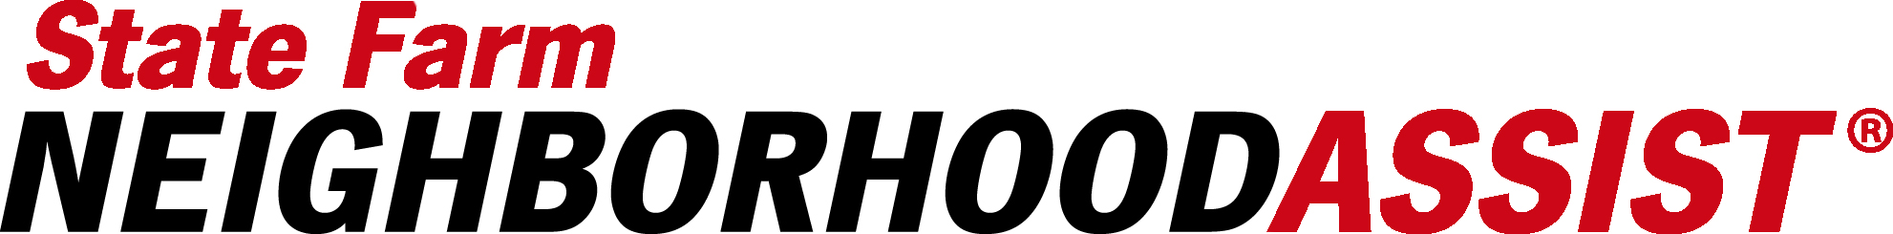

Neighbors across the country will soon have an exciting opportunity to help change their communities for the better through State Farm Neighborhood Assist®. As a company, State Farm® continues the effort through Neighborhood of Good® to inspire and empower people to turn caring into doing. As part of this platform, State Farm Neighborhood Assist is back for its seventh year in 2018.

State Farm invites the public to submit a community cause about which they’re passionate and to rally behind that cause for a chance to win a $25,000 grant through State Farm Neighborhood Assist. Anyone 18 years of age and older in the U.S. can participate. Here’s what you need to know:

- The cause submission phase is open from June 6-June 15 or when 2,000 submissions are reached, whichever comes first.
- You can submit one cause in one of the three categories of safety, community development or education.
- All you have to do is submit the cause; you don’t have to “run the program.”

State Farm Neighborhood Assist, a crowd-sourced philanthropic initiative, lets communities determine where grant funding is awarded. The application is short and simple, and I encourage you to learn more by visiting www.neighborhoodassist.com. You, or someone you know, could be the catalyst for positive change to your community cause!

Your application will be judged based on your answers to the following three questions:

- How much does your “Cause” focus on an unmet need in this community?
- Why do you feel the $25,000 would address the unmet need?
- How much of a lasting impact on this community would the proposal have?

After the submission phase ends, the State Farm Review Committee will read and narrow down all the submissions to the top 200 finalists.

Once the top 200 causes are identified, they will appear on www.neigborhoodassist.com to be voted on -by you and your community. The voting phase will last from August 15-August 24 and each person gets up to 10 votes per day, every day during those 10 days.

The top 40 causes with the most votes will each receive a $25,000 grant from State Farm!

Winners will be announced on September 25 at www.neighborhoodassist.com.

Key Dates for 2017 State Farm Neighborhood Assist:
• Submission phase: June 6-June 15 or when 2,000 submissions are reached, whichever comes first
• Voting Phase: Aug. 15-Aug.24
• Winners Announced: Sept. 25

For more information contact your Public Affairs Community Specialist:
Kim Conyers
kim.conyers.gpqc@statefarm.com
910-32-1636 (cell)

