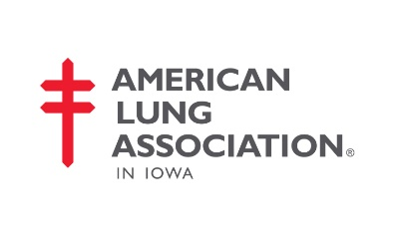
Join the Movement…
Be a Role Model in Indianola…
Become a Tobacco-Free Worksite…

- Tobacco use is the leading cause of preventable death and disease in the United States.

- Use of some tobacco & nicotine products (e.g. E-cigarettes) are rising in Iowa and across the U.S. One in 8 teens are current e-cigarette users and that number continues to dramatically increase across demographics. It’s one of the more pressing public health issues facing us right now and we must take important steps in our community to protect everyone’s health and safety!

- The Iowa Smoke Free Air Act does not prohibit the use of smokeless tobacco and E-Cigarettes under current law. As a result, many worksites in Iowa haven taken the essential & necessary step to update their worksite policy from smoke-free to tobacco-free. This is in compliance with Iowa Statutes Section 142D.5, which supports worksite policies that are stronger than state law.

- By implementing a tobacco-free worksite policy, you can protect the health of your customers and employees. This critical change will not only improve everyone’s quality of life, it will also save you a lot of money!

- It’s EASY to become a tobacco-free worksite and the American Lung Association is here to help!

The American Lung Association in Iowa is dedicated to providing free tobacco cessation and education resources in your county.

The American Lung Association can provide:
• Free expert assistance to update your current policy or create a policy for your worksite
• A free, comprehensive toolkit that provides step-by-step guidance for implementation
• A free, onsite Freedom From Smoking® tobacco cessation class for your employees
• Free metal signage and window clings for buildings, doors, property and more!
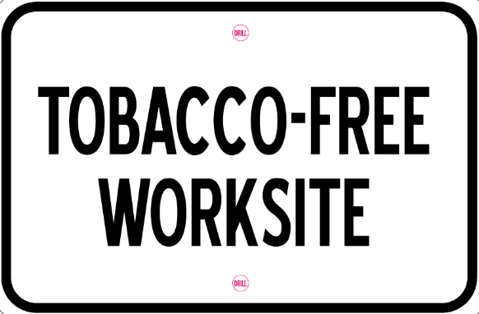

Do you already have a tobacco-free policy? We want to hear about it!
You will also be eligible for free resources!

Contact us to learn more:
- Brian Vanderheyden, Mission Coordinator, Tobacco Control
- Brian.Vanderheyden@Lung.org, (515) 418-9855

