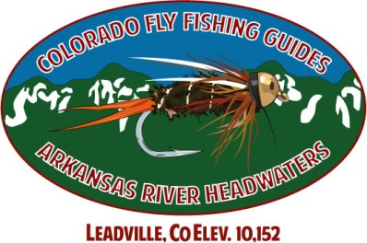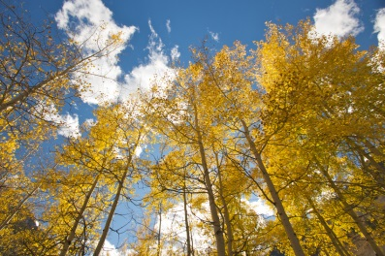
FALL SPECIAL
20% OFF
½ DAY GUIDE RATES
Receive 20% OFF any 1/2 day guide rate booked by 10/31/13 and completed between 9/3/2013 and 10/31/2013.
1/2 day Guide Rates
1 person $205 ...... 20% OFF = $164
2 person $290 ....... 20% OFF = $232
3 person $395 ....... 20% OFF = $316
Guide rate includes use of gear and flies. Snacks, water, and soft drinks provided.
Call us to book your trip for some great fall fishing!
COLORADO FLY FISHING GUIDES
866 908 7547

