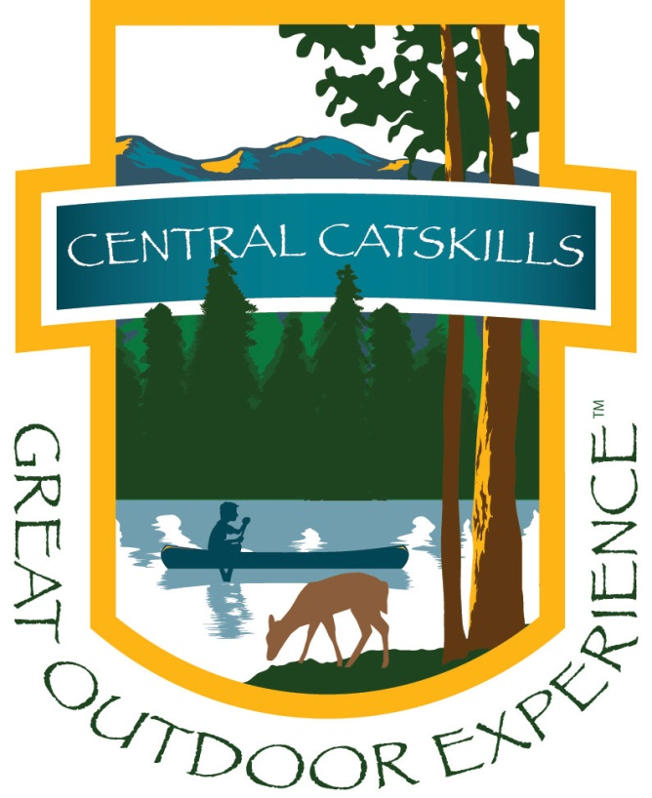
Central Catskills Great Outdoor Experience Festival Schedule of Events/Activities August 24, 25, 26, 2012
Friday night: 7:30pm Star Gazing at the grassy field behind the DURR on Route 28, Arkville
Songs and Storytelling around a campfire with James Krueger and Craig Appolito of Catskill Outback Adventures and Tours.. Highlights of the summer/autumn sky, viewing some prominent constellations and how to identify them will be some of the interesting topics presented by Professor of Astronomy Jason Smolinski at SUNY Oneonta. Do you have a cell phone or tabloid then you might want to download anyone of the free or inexpensive APPs such as Night Sky so that you can follow along. There will be telescopes available for viewing too. Bring chairs and blankets. No Charge

Saturday - 10 - 4pm Festival on Main Street and Binnekill Parking area in Margaretville
- Paddle in a Kayak, Zip along the Ropes Course, learn how to Fly Fish or Climb a Rock Wall
- Discover the Catskills Fire Towers
- Fly Fishing Game for Kids
- Visit the Stream Table and learn about Stream Dynamics
- View an Historical Outdoor Recreation Exhibit
- Roxbury’s WIOX Community Radio
- Just for the Kids – Arts and Crafts Tent
- Canookie Fun – Now you will know what a Canookie really is. Yummy.
- Chicken BBQ, Hot Dogs, Hamburgers, Sausage and Peppers, Lazy Crazy Acres Ice Cream, Italian Ices, Kettle Pop Corn, Lemonade and Fresh Fruit Drinks
- Shop our Vendors, Visit our Main Street Galleries and Specialty shops.
- Wine Tastings at Margaretville Liquor Store on Main – 12 – 4pm Complimentary
- Entertainment Tent – all day long
10am – 11am - Learn about Back Packing
11am – 12pm – Balloon Sculpture and Magic
12:15pm – 1pm – Catskill Mountain Boys
1:15pm – 2pm – Jason Starr Sing Along Celebrates American music family style
2:15pm – 3pm – Catskill Mountain Boys
3:15pm – 4pm – “Pepacton” – excerpts from the original play performed by Open Eye Theater

- Kelly Hollow Beaver Pond Hike at 4pm with members of the Catskill Mountain Club up the Kelly Hollow trail to watch the amazing beavers. Kelly Hollow is a lovely short trail with mountain streams and a combination of coniferous and mixed forests and an active beaver pond at the top. Located on Millbrook Road in the town of Middletown, NYNJ Trail Conference map #42, F-5,6. Easy to moderate loop of about 4 miles with a lean-to and privy at the top. The late afternoon is a good time to catch beavers at work. Time: 3 to 3 1/2 hours. Bring water, snacks and camera. You may want to bring a flash light as we'll be coming down at dusk and going through a dark (and spooky) Red spruce forest. This event is limited to 10 people and dogs are welcome although they will have to be kept away from the beavers. Meet at the Old Schoolhouse 2.2 miles west of Margaretville, NY at 4:00 pm or at the trail-head at 4:30 pm. Directions to the trail head from the Old School House: Go right (west) on the NYC reservoir road across from the Old School House for 3.7 miles. Then left on Millbrook Road for 5.3 miles to the trail-head parking area on the right. Contact: Howard Raab, (845) 586-3112, howardjraab@gmail.com Rain cancels.
Sunday – Various Times To Get Your Great Outdoor Experience
Sign up for any of these Adventures at the Festival on Saturday

- Fly Fishing Field Trips by Catskill Outback Adventures and Tours – James Krueger, licensed guide
Meet at Catskill Outback Adventures shop next to the Margaretville Motel on Route 28, Margaretville
Options: 7:30am – 11:30am or 3:30pm – 7:30pm. $35 per person includes equipment. Must have NYS Fishing License.

- Cycle the Pepacton sponsored by the Catskill Mountains Cycling Club – CMCC Member Ron O’Connor
Meet at the Binnekill Parking area near the walking bridge in Margaretville by 9:45am
Ride will follow Route 28 out of Margaretville, left turn at Stone School House to Southside Road. Follow Southside Road to Shavertown Bridge and view of Pepacton Reservoir - Return along same route back to Margaretville
Mileage: 25 miles, Activity Level: No Climbs, Rolling Hills, No Charge
Port a Let is available at the Arena Launch site parking lot. Bring own water and snack.

- Paddle the Pepacton Reservoir - CMC Board Member Ann Roberti - 11am - 3pm
Meet at Arena Launch site. $15 cost to Steam Clean – Must be done before arrival at Arena. Access Permits also needed and can be gotten at Steam Cleaning Station or www.nyc.gov/dep/recreation or 1-800-575-5263.

- Ropes Challenge Course at Catskill Outback Adventures and Tours home on Route 28, Big Indian –
9am – 4pm Try this forested challenge course for fun and adventure. $30 per person. Sign up at the Festival

- Belleayre Beach and Lake – Make a Walking Stick – 11 am Meet at Pavilion at Belleayre Beach the NYS DEC facility located off of Route 28 in Pine Hill There is an $8 entrance fee per car to the Beach. Bring a picnic lunch and your bathing suit.

- Hike to Balsam Lake Mountain Fire Tower to mark the 125th anniversary as the site of the first fire tower in NYS. To hike the Summit leave Millbrook Road trailhead at 8:30am. Following the hike return to the Catskill Center from 3 – 5pm when you can meet authors: Marty Podskoch, author of Fire towers of the Catskills, Diane Galusha author of Civilian Conservation Corps in the Catskills, and Dave and Carol White author of Catskill Day Hikes. These well-known authors will also speak, answer questions and offer their books for sale. Jeff Senterman, the NY-NJ Trail Conference’s Catskill Region Program Coordinator will host the event and speak of the Trail Conference’s stewardship efforts in the Catskills.

- Rochester Hollow – 10 am for a hike of 4.6 miles to estate ruins. Mostly level walking on a scenic old woods road with a few slightly steep spots. Creek, open woods, hemlock forest, memorial plaque, old stonework and foundation remains from long gone estate. Bring water. No lunch. The trail is easy, about 5 miles in and out. We should be done by 1pm at the latest. Directions: From Route 28, 1 mile west of the intersection of 28 and Rt 47 in Big Indian, turn north on Matyas Road. .1 miles to parking area. A Catskill Mountain Club member guided hike.

- Hike with John Exter for a 10 am Big Indian area hike. Meet at the Trail Head at the end of Matyas Road - a short dead end that leads north from Rte 28 one mile west of the Rte 47/Rte 28 junction in Big Indian. The trail is easy, about 5 miles in and out. Hike should be done by 1pm at the latest. Bring water. No lunch. Sign up at Catskill Mountain Club table on Saturday.

- Andes Rail Trail -- 2 miles begins at 1 pm. Join Catskill Mountain Club board member Laura Battelani for a leisurely hike on this newly created trail in the town of Andes. It travels on the old D & N Railbed for one mile of flat, scenic terrain. Meet at the trailhead. Park in town and walk to trailhead or park in the Greenfish parking lot just below the trailhead. Directions: From the flashing light on Route 28 in Andes, go a short distance west on County Rt 2, aka Depot Street and Cabin Hill Road to the gate in front of the Andes Train Depot.

