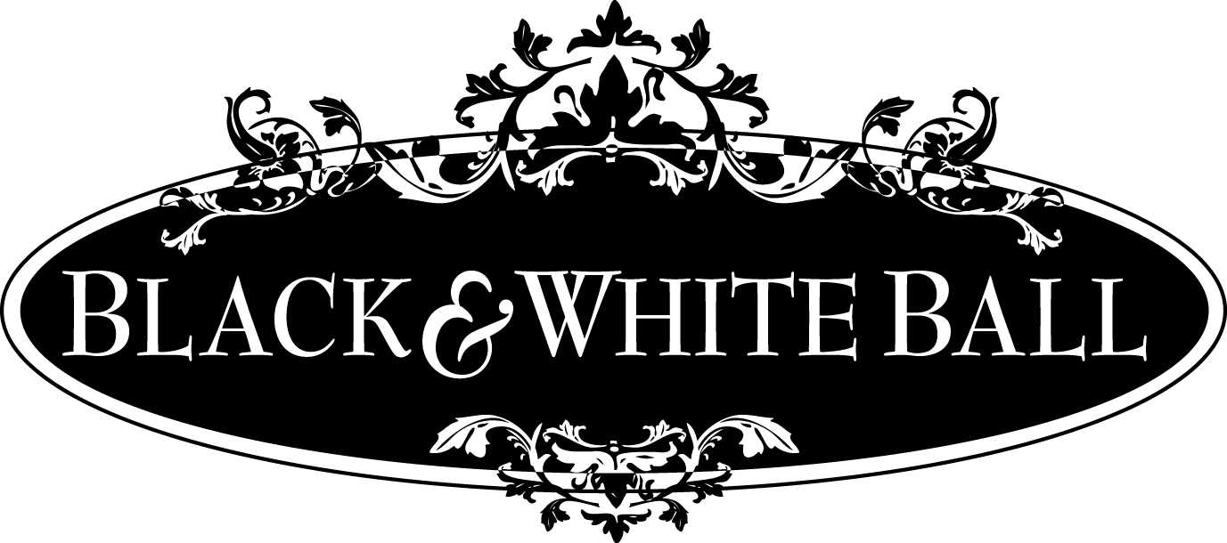
Keynote Speaker
Christine Webb, Channel 13 News

Women of Excellence AWARDS GALA
Thursday, May 21st, 6PM – 9PM at the Hilton Melbourne Rialto Place

Sponsorship Opportunities
Your company can be a part of the Women of Excellence Awards Banquet hosted by the Melbourne Regional Chamber of East Central Florida where we recognize chamber women in the community for their dedication and commitment to excellence. This year’s Black & White Ball will be held Thursday, May 21st at the Hilton Melbourne Rialto Place from 6PM – 9PM. All WE Award nominees will be recognized and TWO outstanding women will be presented with the prestigious 2015 Award of Excellence.

$2000 – Presenting Celebration Sponsor
- Reserved seating for eight (8) with signage
- Presentation of award from podium
- Logo on all promotions and media
- Marketing display at event (provided by sponsor)
- Company logo on chamber’s website with link to company

$1500 – Keynote Speaker Sponsor
- Reserved seating for eight(8) with signage
- Introduction of Keynote speaker
- Logo on all marketing materials
- Display table at event
- Logo in program and on screen at event

$1000 – Cocktail Reception Sponsor
- Reserved priority seating for eight(8) with signage
- Name on event program
- Name on scrolling screen at event
- Recognition from podium
- Logo on all promotional materials
- Signage at cash bars
$750 – Corporate Table Sponsor
- Reserved seating for eight (8) with signage
- Name on event program
- Name on Scrolling screen at event
$250 – Event Sponsor
- Reserved Seating for 2 people
- Listed in Program

Women of Excellence AWARDS GALA
SPONSORSHIP FORM

Please note: The listings of these opportunities does not guarantee availability and specific sponsorship openings must be confirmed with chamber staff.

Yes, I agree to be a _______________________________________ Sponsor for $ _________________________
Company Name _______________________________________________________________________________
Contact person ________________________________________________________________________________
Phone _______________________________________ Email __________________________________________

I need ________________ additional tickets for $50 per person

Payment Method (circle one): Enclosed Check Invoice Me Master Card Visa Other:_______________

Credit Card Number: ________________________________________________________ Exp. ______________
Authorized Signature of Cardholder: ______________________________________________________________

Please email this form to Naomi Penney at Naomi@melbourneregionalchamber.com or fax to 321-725-2093.

WOMEN OF EXCELLENCE MISSION STATEMENT:

To empower the diverse working women of our community to achieve their highest potential through collaborative initiatives, focusing on networking, professional development and community outreach.

