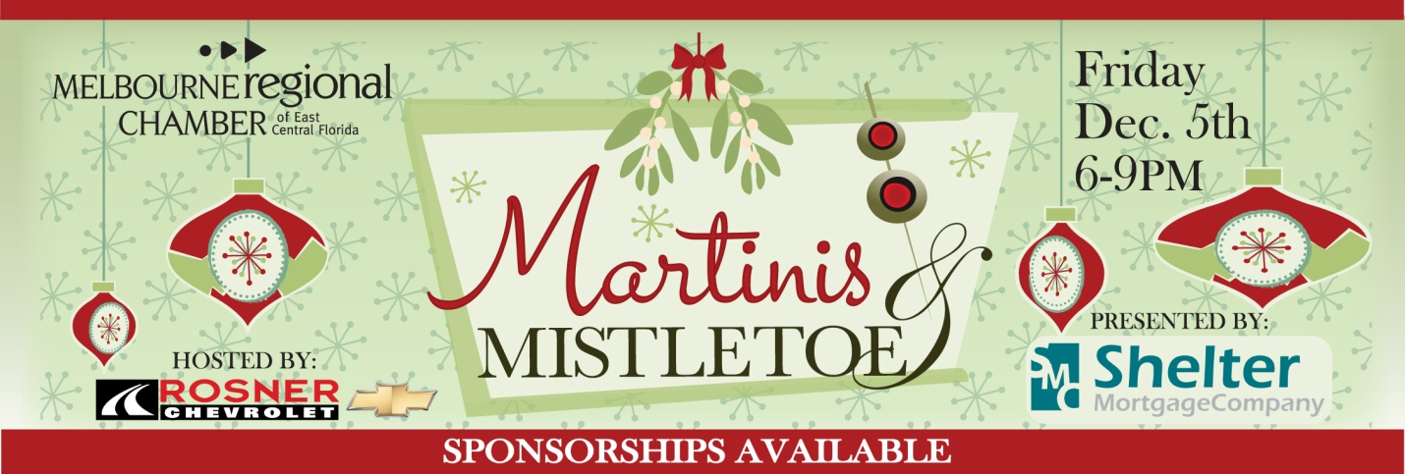
Your company can become part of the annual Martini’s & Mistletoe event hosted by the Melbourne Regional Chamber of East Central Florida, and presented by Shelter Mortgage. We will be awarding the Best Martini on the Melbourne Coast the evening of December 5th, 2014. The event will be held at Rosner Chevrolet located on US 1 Melbourne from 6-9pm. The evening will give 300 plus in attendance the chance to sample, savor and vote for their favorite Martini on the Space Coast. Over 10 local bars, restaurants and martini aficionados will compete with their best martini recipe!
- Presenting Sponsors- $2000 (To date: Shelter Mortgage)
- 10 attendees to the event
- Priority reserved parking
- Name/logo on all marketing materials, press releases, print ads, social media, radio, postcards
- Two- five minute commercial during event-
- Company signage and or banners at event with display table
- Silver Sponsors-$1000
- 6 attendees to event
- Company partnered with a Martini Bar contestant, company name on signage displayed at bar
- Company listed on e-vites, website and newsletter promotions, social media and print ads
- Special recognition from microphone night of event
- Martini Bar Sponsor-$500
- 5 attendees to event
- Company partnered with a Martini bar contestant, company name on signage displayed at bar
- Company listed on newsletter promotions
- Meet Me Under the Mistletoe Sponsor - $250
- Your company name hanging from your very own cluster of mistletoe and 2 tickets to event

Yes, I agree to be a ______________________________________ Sponsor for $_______________

Company Name ___________________________________________________________________
Credit Card:_____________________________________exp.________________sec___________
Signature________________________________________________________________________
To reserve your sponsorship contact Chuck Galy Chuck@melbourneregionalchamber.com 724-5400

