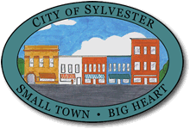
Downtown Talent Showcase
Participation Form

NAME: ______________________________________________________________________

PARENT’S NAME:

ADDRESS: __________________________________________________________________

EMAIL:

TELEPHONE: _________________________________________

AGE: ___________________

TALENT: _____________________________________________________________________
If the act requires recorded accompanying music, the music must be:
- Provided on a CD
- CD’s must be labeled with name(s), song name, and artist/composer.
- Music accompanying singing acts must be instrumental only – karaoke style music.
- CD’s will not be returned until after the talent show. Make an extra copy of the music so that it is available to you or your group for practicing.

