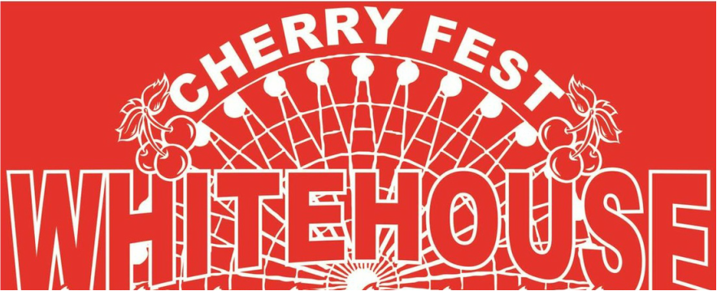 2016 Sponsorship Opportunities

Celebrating 34 Years of Cherry Fest!

Parade Sponsor
$750.00
- Logo on ALL WTOL-NEWS 11 commercial spots
- 800 Digital Ad Impressions (10 Sec. each) on digital billboard on Route 64 in Whitehouse
- Website banner on Chamber Homepage and Cherry Fest homepage
- 20 tagline promotions via PA system over the 3-day festival, which draws over 10,000 people
- 25 tagline promotions during the Cherry Fest parade, which draws over 5,000 people on main street
- Your company logo on: 15,000 direct mail flyers mailed out, 150 posters, 5-6 print ads, 2,500 festival brochures, and 100 festival volunteer t-shirts

Main Attraction Sponsor
$500.00
- Logo on all WTOL-NEWS 11 commercial spots
- Logo on 5-18”x24” promotional signs in and around the main attraction
- Logo on 15,000 direct mail festival programs mailed out June 1, 2016
- Website Banner Ad on Cherry Fest Home Page
- 15 Tagline promotions on stage during both days of festival which draws over 10,000 people
- 5 Tagline promotions during Parade which draws over 5,000 people on Main Street
- Your company logo on: 150 posters, 5-6 print ads, 2,000 festival brochures, 100 festival volunteer t-shirts
- Logo on 8-3’x5’ promotional banners in and around Beer & Wine Garden

Entertainment Venue Sponsor
$150.00
- Logo on 5 promotional 18”x24” signs
- Logo on 15,000 direct mail festival programs mailed out June 1, 2014
- 1 Tagline promotion on stage before each talent act up to 10 talent acts
- Your company logo on: 150 posters, 5-6 print ads, 2,000 festival brochures, 100 festival volunteer t-shirts

If you are interested in being a Cherry Fest Sponsor, please Contact Abbey Hall at 419-877-2747 or by email, abbey@awchamber.com

*******Commitment due by May 15th to secure YOUR logo on all advertising for festival********

