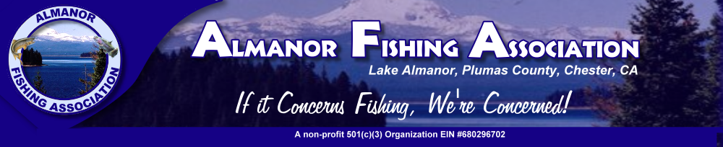
2019 News
2018 NEWSLETTER

PRESIDENTS MESSAGE: As a member and volunteer of the Almanor Fishing Association for the past four years, I have witnessed firsthand the dedication and work ethic of our volunteers.
Our fish pen program is the longest running most successful fish rearing program in the state. Our feeders are a close-knit group. We feed under some very adverse conditions and take pride in the fact that we did not miss a day of feeding this past year.
We recently collaborated with Dallas Tognotti and the ARI program at Chester High School to assist Dallas in the rearing of Brown Trout at his facility. We have been feeding the Browns daily since the end of the school year. Our feeders have not missed a day and the Browns have prospered.
I am proud to represent these volunteers as we serve our member’s and our community. Collectively we are fostering relationships with guides, fishermen, CF&W, ARI, Feather River College, Field of Dreams, Chester Elks Lodge, PG&E, businesses and members.
I would like to thank the AFA Board for entrusting me to serve as president, it is my honor to work with all of you to enhance and promote our great fishery. John Crotty

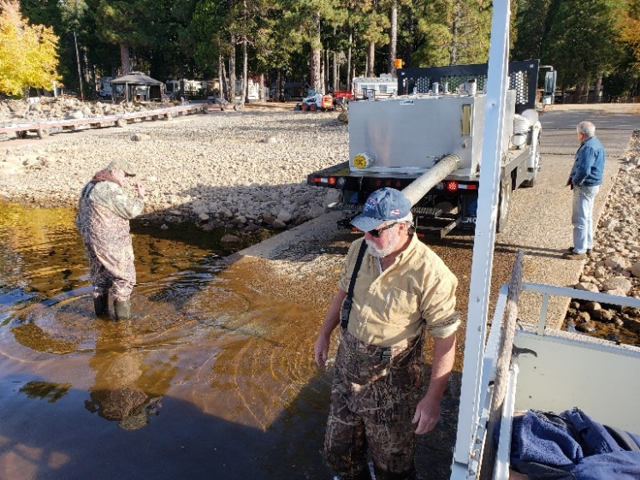

In 2018 AFA participated in the second annual Veterans Fishing Day on Lake Almanor. We partnered with local guides and fishermen, PG&E, California Fish & Wildlife, Chester Elks Lodge and Field of Dreams. 27 boats provided 47 Veterans with a day of fishing followed by a barbecue at the Chester Elks Lodge.
AFA, Field of Dreams and local guides hosted seven fishing trips for Field of Dreams Veterans on Lake Almanor. Fourteen Veterans were treated to two nights lodging and a guided fishing trip. One of the participants who is a Vietnam Veteran and suffers from PTSD returned and informed us that his trip was one of the top five experiences of his life. AFA is honored and proud to provide these opportunities for our Veterans.
AFA is assisting Chester High School, teacher Dallas Tognotti and students of Almanor Research Institute (ARI) in the rearing of Brown Trout at the ARI facility. AFA volunteers have been feeding the Browns daily since the end of the school year, (we have not missed a day). In early December AFA and ARI transferred 1,500 of the Browns to a vacant pen at the Branch. This is the first time we have attempted to raise Browns in our pens. AFA will feed these fish daily along with our Rainbows. We are cautiously optimistic these Browns will continue to prosper and double in size prior to their release in early spring.
AFA is excited to announce that with assistance from California Fish & Wildlife Biologist, Amber Mouser, we are partnering with Feather River College’s Adam Fuller and the FRC hatchery program to raise 50,000 fertile Browns at the FRC hatchery to fingerling size with intentions of moving the Browns to our fish pens at Hamilton Branch. With CF&W cutting back on Brown plants and the fact that Almanor is well known among fishermen as a world class brown fishery, we are thankful to Amber, CF&W, Adam Fuller, Feather River College, Dallas Tognotti, Chester High School & ARI as we collectively work to enhance our brown fishery.
Fish pen program:
AFA recently received 50,000 Shasta Lake, fertile, twelve to the pound Rainbows into our fish pens. This is the first time in years that we have received 50,000 fish .
To prepare for this years’ fish delivery, AFA spent over $10,000 repairing pens and installing log booms to protect the repaired pens. LACC provided us with six large cedar logs for the booms and Almanor Anchor installed the boom and welded the pens. After pricing cedar logs and transportation to Hamilton Branch, LACC saved AFA a substantial amount of money. In addition, we were able to secure six cedar logs from LACC residents Jim Kennedy and AFA Board member Robert Gonzalez. A volunteer work party of sixteen men worked alongside timber faller Spike to fall the trees, remove limbs and haul approximately thirty loads of debris to green waste. The work resulted in six more large cedar logs that are currently stored and seasoning at Rec#1. What a testament to AFA, our volunteers and the generosity of the Lake Almanor community.
In past years AFA has utilized constant contact to keep members informed and updated via e-mail. Through the generosity of Salesforce and Duncan McIntyre JR. AFA will be utilizing a computer program donated to AFA by Salesforce. Duncan works for Salesforce, Salesforce is ranked #1 on Fortune’s annual top 100 best companies to work for.
In addition to the donation of this program, Duncan donated countless hours to AFA to establish a data base that will allow us to send periodic updates and other information to our members. I don’t understand all that this program can/will do for AFA, but I do know it will save us time and money, allow us to keep accurate financial records, keep our members informed and allow us to utilize social media to promote Lake Almanor and our fishery. In addition, Salesforce matched Duncan’s donations to AFA with a $2,500 check!

2020 MEMBERSHIP:
We have included a membership form to mail in: P.O. Box 1938 Chester, CA 96020
or please
Visit our Website: almanorfishingassociation.org
to join and pay on line
