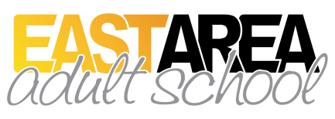
Invest in the future of our county!
Be featured in our Graduation Program brochure
Low graduation rates affect our neighborhoods and economic conditions. Individuals lacking a high school diploma or GED are more likely to commit crime, seek welfare, and remain on assistance longer.
What a difference a high school diploma or GED brings to an individual, to their family, and in our neighborhoods, county, state and nation!
How can you invest in the future of our wonderful Polk County??
$20 TABE assessment (Reading, Language, Math)
$30 Tuition for one student for one Term (August-December or January-May)
$60 Tuition for one student for one full school year
$32 Fee for one subject area GED test (There are 4)
$128 Fee for one student to take all 4 subject area tests for the GED
OK, so how can you help just one student??
$82 Invest in one student’s assessment, one term of classes, & 1 GED subject area test
$144 Invest in one student’s assessment, one full year of classes, & 2 GED subject area tests
$208 Invest in the total potential cost for one student for one year and all 4 GED subject area tests
Join our Investment Club – No end to the benefits!
PLATINUM Member
$416 or more for 2 or more students

GOLD Member
$208 for everything for one student
SILVER Member
$144 for one student for one year & 2 GED subject area tests
BRONZE Member
$82 for one student’s assessment, one term of classes, & 1 GED subject area test

Honorable Mention Member
Any amount $10 - $80

Any amount will make a difference. Your contribution is tax deductible, and you, your family, business, or organization will be featured on our Graduation program in May and given out to everyone attending.
How? Make checks payable to East Area Adult School
Mail or give your check to Brooksie Smith, Beverly Putnam, or Dr. Danielle DeConcilio at:
East Area Adult School, 300 E. Bridgers Ave., Auburndale, FL 33823 Ph: 863-965-5475

