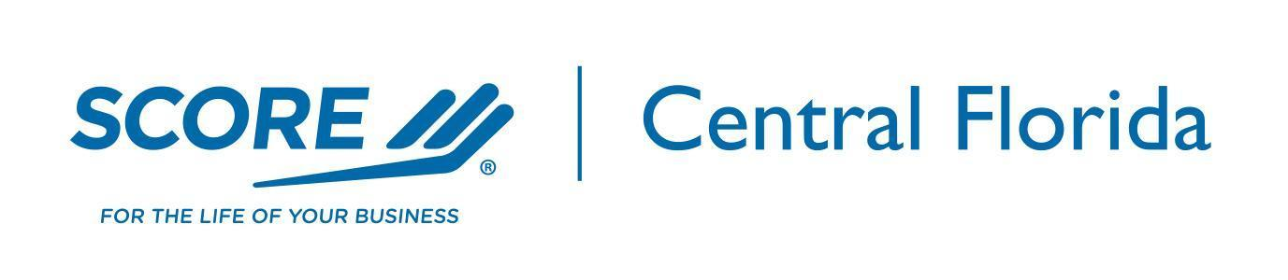

2026 BUSINESS EXPO
EVENT PLAN
As of 2/24/2026

Event Overview

This event will be held on April 30 on the Catapult campus in the Assembly Room. This will be a 4 hour tradeshow format event offering 3 interactive sessions covering finance, marketing and networking during the event for those interested. The event will include a continental breakfast, opportunities for attendees to sit with vendors at their tables, 3 short sessions and a speed networking opportunity for attendees.
Speakers will come from the vendors / sponsors or partners at the event. Each will have approximately 30 minutes to discuss a question or issue that we agree is relevant to our clients.
A speed Networking session will be run by SCORE volunteers.
The event will include an exhibit area for Sponsors And Partners. Attendees will have the opportunity to visit and interact with exhibitors throughout the duration of the event.
As a non-profit organization, SCORE’s goal is to help, through education and mentoring, as many local prospective and existing small businesses as possible. This event is designed to engage the combined resources of SCORE and community-oriented businesses, to support SCORE’s 2026 education program and generate increased mentoring opportunities.
Based on previous years an attendance of 80-100 current and prospective businesses are expected.
Event Venue

Established in 2014 by the Lakeland Economic Development Council, Catapult was created to foster the growth of startups.

Inspired by visits to entrepreneur centers around the United States, the LEDC launched Catapult in the basement of the Bank of America building to see if entrepreneurs in the community desired a place to collaborate.

Since then, Catapult has grown into a vibrant hub in downtown Lakeland, featuring three distinct incubators—Workspace, Makerspace, and Kitchen—each designed to support and accelerate the growth of businesses.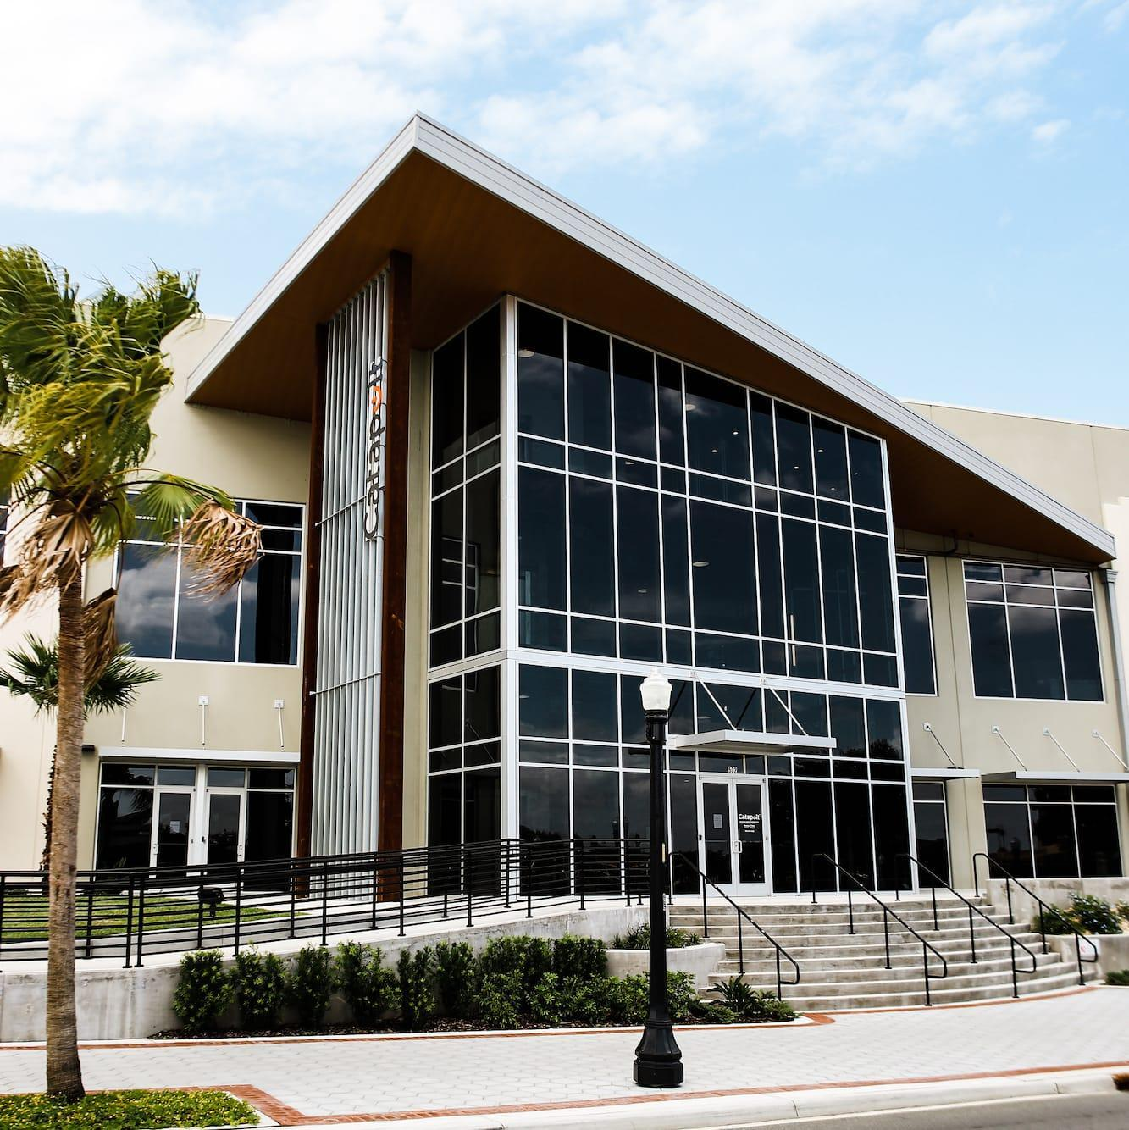
As a privately funded non-profit, we impact the local economy by:
- Increasing the viability of startups in Lakeland
- Launching companies into brick and mortar spaces
- Connecting corporations and the startup community
- Providing value-added educational opportunities

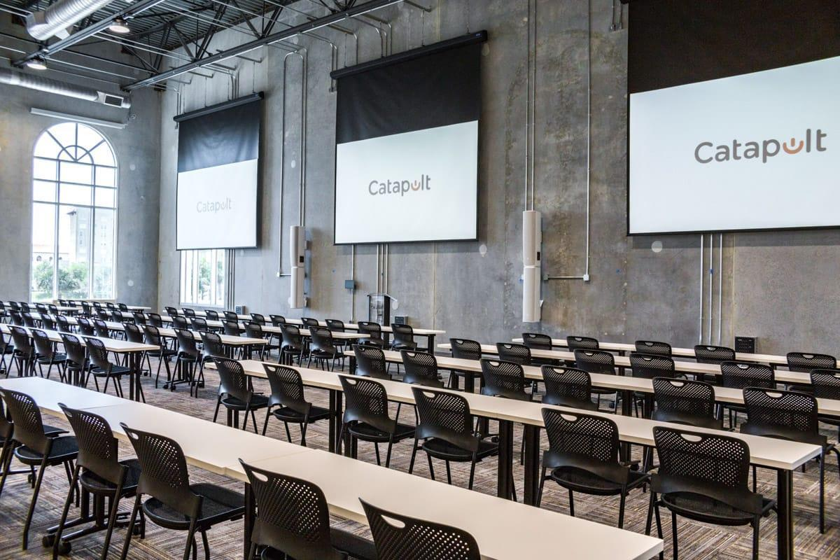

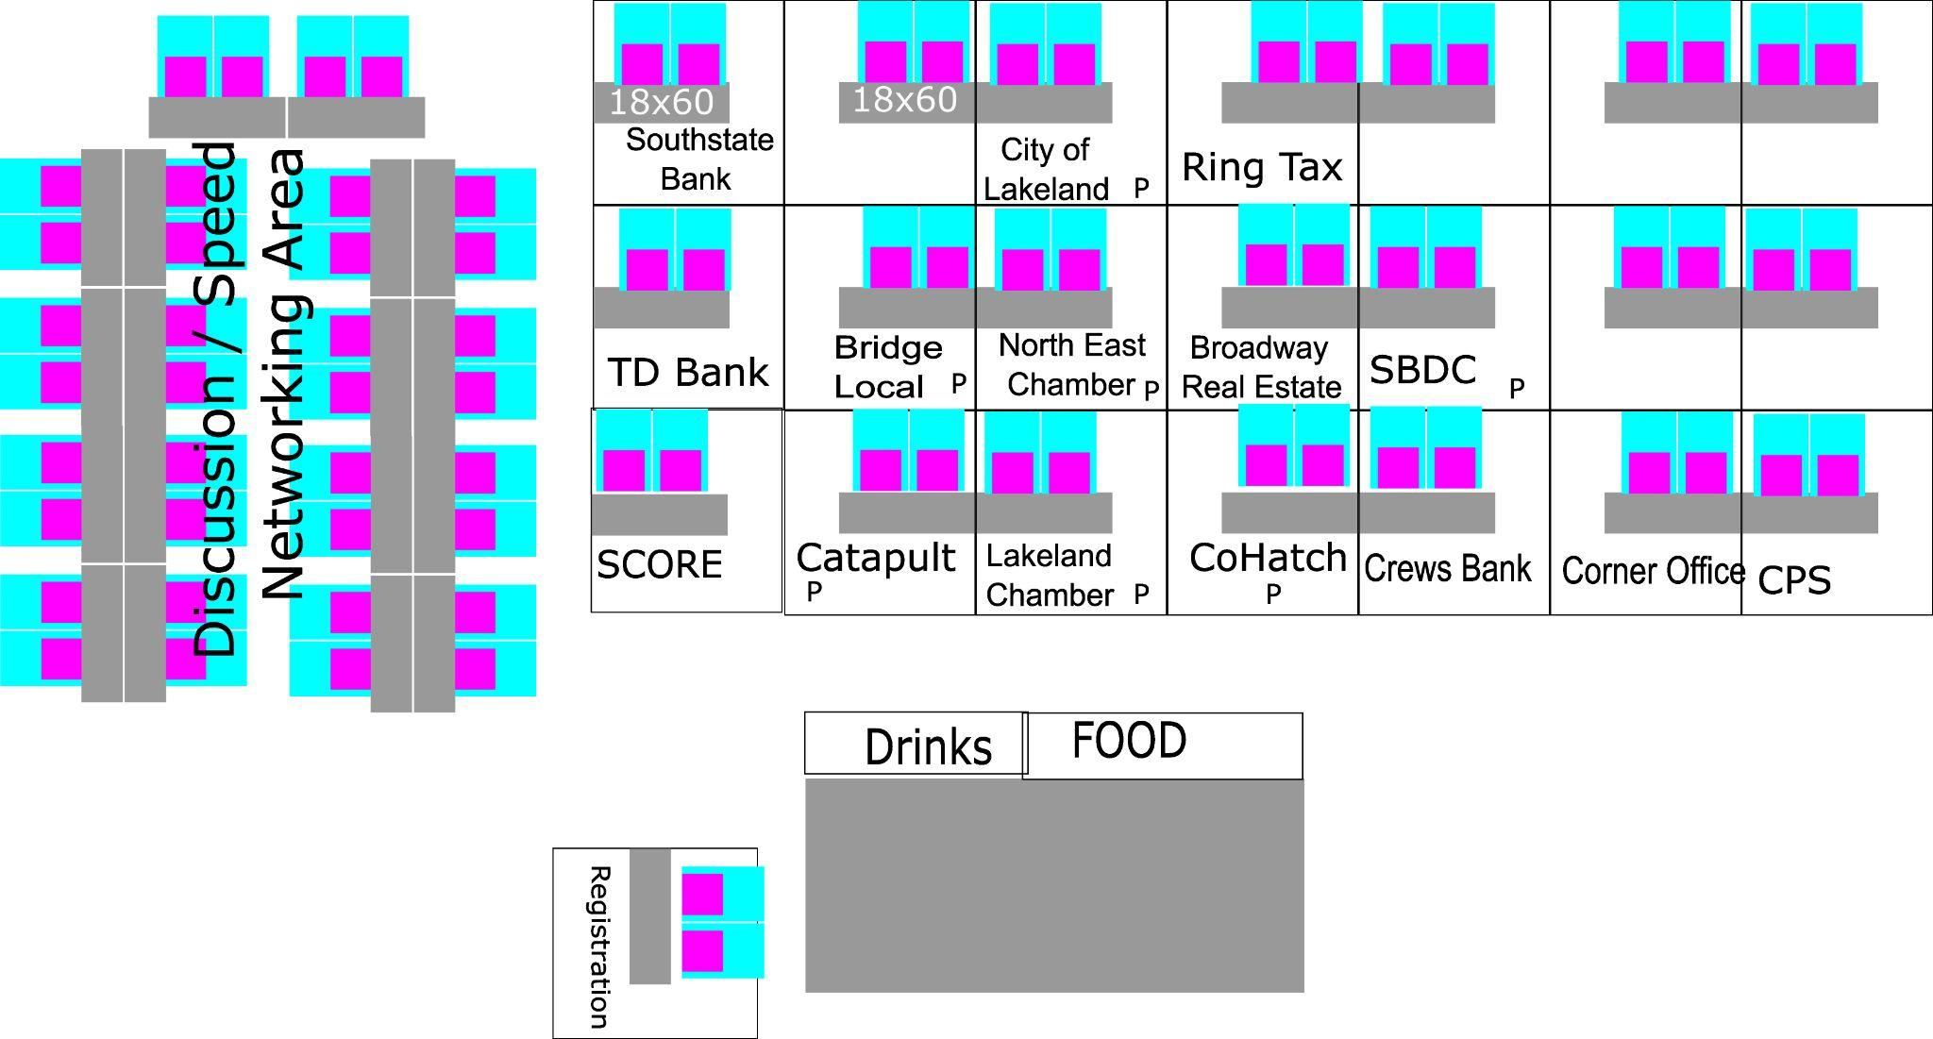

Event Program

8:30 - 9:00 am Vendor / Sponsor Set-up

9:00 - 9:15 am Introductions

9:15 - 10:00 am Breakfast and tables open

9:15 - 9:45 am Financing Discussion

10:15 - 10:45 am Marketing Discussion

11:15 - 11:45 am Networking with Chambers of Commerses

12:00 pm -12:45 pm Speed Networking

12:45 pm - 1:00 pm Final Thoughts - Close of event

1:00 pm - 1:30 pm Clean Up Exit Building

Tickets

To cover the cost of the event space, refreshments and a parking pass for attendees we are asking for a sponsorship amount of $200.00 per table. If you are willing or able to give more we would appreciate the support. At the $1,000.00 level the table is free at this event and the Womans Business Summit in September.
Partners with a Sponsor Agreement (Silver and above) in place have a table included at all live events.
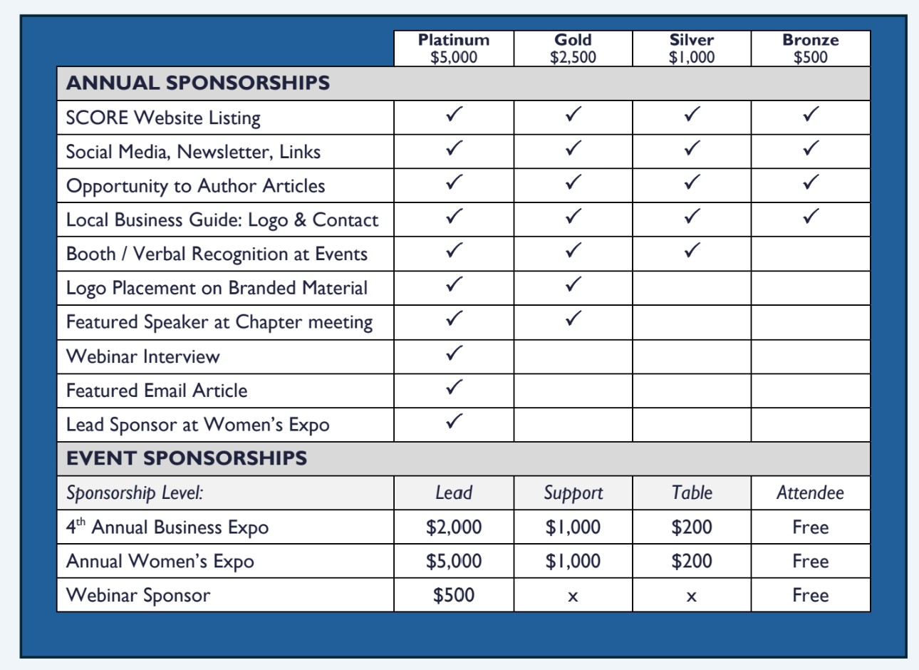

If you would like a table please contact Rich Weiss via email @ r.weiss@scorevolunteer.org or Jeff Christoffersen via email @ jeff.christoffersen@scorevolunteer.org

