PARKVIEW HOUSING, INC.
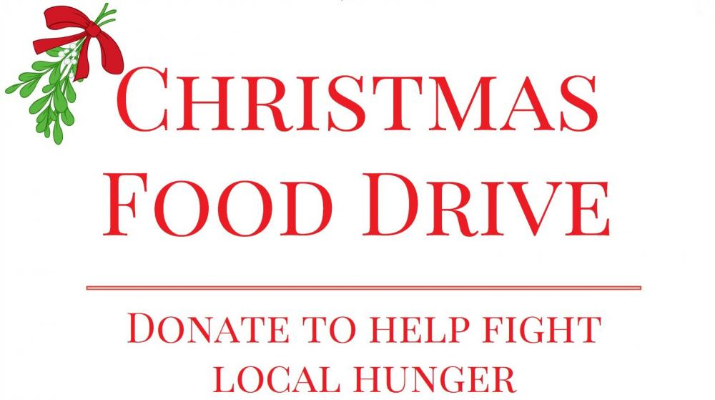
Items needed:
- Stuffing /Gravy Can Greens Black eye peas
- Instant Mash potatoes Yams Macaroni & Cheese (box)
- Rice Can vegetables Cranberries
- Dessert Ham Turkey

Join us in the Christmas Food Basket drive to help families in need.
*Christmas baskets will be distributed to the families of the school children that we support weekly

Please drop off your items:

Parkview Christian Life Center
3520 Baker Avenue
Haines City, Fl 33844
-Donation box in foyer-

Or you can call for pickup- Debra Wright, 321.278.7815

