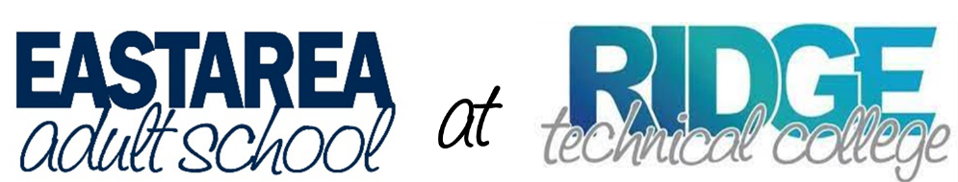

East Area Adult School has joined forces with Ridge Technical College, located at 7700 SR 544 (Lucerne Park Rd.), Winter Haven, FL 33881. We are so excited to bring the GED preparation program to Ridge, and the English for Speakers of Other Languages program closer to the huge population of English language learners in the Davenport, Haines City, and Dundee communities.
The physical move was exhausting, and we continue to adjust furniture, offices, and supplies; however, the classrooms are full and our students are thriving. They have adjusted well to the new procedures and location.
We offer classes during the day and the evening on the Ridge Technical College campus. We also have classes in Davenport, Haines City, Winter Haven Polk State College, and Lake Wales.
Because East Area Adult is on the campus of Ridge Technical College, we will have opportunities to expose our students to the many career programs offered through the technical college. We have enrolled over 450 students during August, both in person at all locations, and online. We have plenty of room! Registration continues throughout the year, so continue to tell everyone to join us!
The registration process is:
- Come to Ridge Technical College and fill out all the registration paperwork. Monday-Thursday 9am-1pm; Tuesday, Wednesday, Thursday 5:30-7:30pm.
- Look at the list of class locations and times to decide which location you will attend.
- Decide if you want to attend in person or online, or both.
- Make a reservation for your placement test. (plan for 2-3 hours)
- Come to test, pay $50 ($20 for placement test; $30 for class)
- Start class.

Contact 863-419-3060, Ext. 802 for more information.

