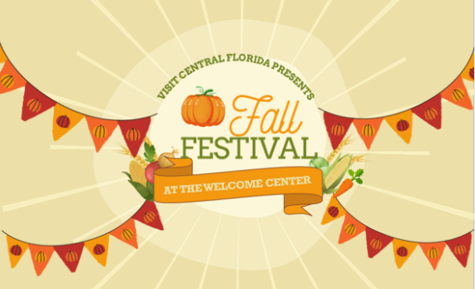

Visit Central Florida’s Welcome Center
FALL FESTIVAL 2025
Saturday, October 18, 2025
9:00 a.m. – 12:00 p.m.
Located at: 101 Adventure Ct. Davenport Florida 33837

PURPOSE OF EVENT: Visit Central Florida’s Fall Festival at the Welcome Center (herein after referred to as VCF Fall Festival) is designed to serve the community by providing a ‘trick or treat’ event for families, to bring community awareness to the Welcome Center, and highlight local businesses (by being vendors). Vendors are responsible for purchasing a minimum of 500 pieces of candy (The WC will provide candy if/when a vendor runs out).

Please contact the VCF Fall Festival coordinator to reserve your spot for the event. Vendors may also distribute their marketing materials to promote their business.

VCF Fall Festival Coordinator Contact Information:
Katie O’Donnell
kathryn@visitcentralflorida.org
(863) 420-2586
Visit Central Florida’s Fall Festival at the Welcome Center Vendor Rules:

- To participate, vendors must supply 500 pieces of candy minimum.
- All vendors are required to be onsite for the entire event (9:00 a.m. – 12:00 p.m.).
- Set up is from 8:00 a.m. - 9:00 a.m.
- Break down is from 12:00 p.m. - 1:00 p.m.
- Vendors may bring their car to the event location during set up and break down hours.
- Vendors are allotted a 10’ x 10’ space.
- Vendors must also provide their own tents, tables and chairs.
- All vendor materials must fit within the 10’ x 10’ space parameters.
  - Vendors are encouraged to use 10’ x 10’ pop-up tents. Vendors are not permitted to put stakes or holes into the sidewalk pavers or the street. Tie-downs are required (minimum of 15 lbs. weight per leg) and are the responsibility of the vendor. Carport-type tents are not allowed.
- Vendors’ areas shall be neat, attractive, appealing and in good sanitary condition for customers. Vendors must clean up their areas, leaving them in good sanitary condition before departing.
- All vendors are responsible for removing their own trash and providing their own trash containers as appropriate. Dumpsters will be provided for vendors’ trash. Trash cans are provided for general public use. They are not to be used for vendor dumping.
- Vendor Parking:
- Vendors may bring their car to the event location during set up and break down hours. During the event, vendors may street park on Adventure Ct.
- Vendors are not allowed to bring pets to the Welcome Center during the event.
- Vendors must be courteous and considerate of other vendors. Vendors shall not shout or hawk their goods or play loud music. Any verbal or physical abuse by a vendor to another vendor, staff or member of the public is cause for immediate expulsion from the event.
- Vendors may use the inside bathrooms of the Welcome Center.
- No smoking is allowed by or behind booth. The event coordinator will inform vendors where designated smoking areas are.
- Absolutely NO sale of tobacco products on property.
- Absolutely NO sale or consumption of alcohol on county property.
- Political groups, campaigners, or religious organizations must not block the flow of traffic within the event and may not erect stationery signs or stand in one place to promote their activities or collect monies.
- Violation of the above rules may result in a banned of events.
- Any sale of products must be preapproved by the VCF Fall Festival Coordinator.

ACKNOWLEDGMENT:

I, __________________________________________, acknowledge receipt of VCF Fall Festival event policy and rules/regulations. By signing this acknowledgment, I will abide by the rules set forth by The Welcome Center and understand that any violation will result in termination.

Visit Central Florida’s Fall Festival at the Welcome Center Vendor Application

Vendor’s Business Name: ____________________________________________________________________

Vendor Name: ______________________________________________________________________________

Mailing Address: ____________________________________________________________________________

Primary Telephone: _____________________ Cell Phone: _____________________

Email Address: ______________________________________________________________________________

Special Requirements: ______________________________________________________________________

____________________________________________________________________________________________

Vendor must submit copies of all applicable licenses and insurance certificates.

Florida Sales Tax Number (if applicable): ______________________________________________________

Florida Processed Food License Number (if applicable): ________________________________________

Name of Insurance Company: ________________________________________________________________

Insurance Company Telephone Number: _______________________________________________

Comprehensive General Liability Policy Number: _______________________________________

Expiration Date: ______________________________________________________________________

By signing this agreement, the vendor acknowledges receipt and acceptance of the Visit Central Florida’s Fall Festival at the Welcome Center rules and requirements.

____________________________________________________________________________________________
Signature of Vendor Printed Name of Vendor Date

Approved By: __________________________________________________ Date: ______________

