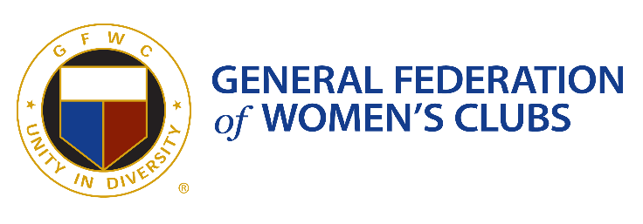 | Contact: Karen Knipling  Phone (407) 376-3994 (mobile)  Email davenportemily@msn.com  GFWC Four Corners Junior Woman’s Club  Website www.GFWCFourCorners.org
Press Release

GFWC Four Corners Junior Woman’s Club 2026 Fashion Show
January 11, 2026 – The GFWC Four Corners Junior Woman’s Club Annual Charity Fashion Show, Luncheon, and Expo spotlights Fashion and Flappers for 2026! The event is scheduled for Friday, February 20, 2026, at Lake Eva Event Center in Haines City. Doors open at 10:30 AM. This is the Club’s main fundraiser for scholarships, assistance to local charitable groups and schools, and serving nearby communities.
Tickets are $40 and include a catered lunch from Carrabba’s. Polk County Sheriff Grady Judd will be the featured speaker. Babe’s Shoes and Apparel will present the fashions. Outfits will be available for purchase at the show. The lobby will highlight local vendors in a tabletop Expo. Attendees are eligible to win door prizes, bid on silent auction items, buy raffle tickets for a chance to win a themed basket of prizes, or enjoy photo opportunities with friends. Wear your finest Great Gatsby-themed attire!
For tickets, please contact Cheryl at (863) 353-8774 or clgmom10@aol.com. The Club continues to collect raffle items, silent auction prizes, and sponsorships from local businesses. Local vendors may contact Pat at (716) 812-5007 for information.
For additional information concerning the organization or meetings, please visit the website, www.GFWCFourCorners.org, email the club at gfwcfourcorners@aol.com, or find us on Facebook.
GFWC Four Corners Junior Woman’s Club is a 501c(3) non-profit organization that reaches out to the Four Corners community of Polk, Osceola, Lake and Orange counties through volunteerism and charitable donations.

