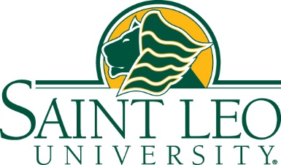

For Immediate Release: October 23, 2020

Saint Leo Board of Trustees Votes to Create a New
Shared Governance Model with Faculty

ST. LEO, FL – The Board of Trustees at Saint Leo University decided Friday (October 23) to no longer recognize the United Faculty of Florida Union at Saint Leo University and approved the creation of a new shared governance model.

In keeping with the university’s Catholic Benedictine identity, the board made this decision in the spirit of helping the university maintain our strong values-based community, innovate, and be more agile in the fast-moving world of higher education.

“As the COVID-19 pandemic has made clear to all of us, we need to be innovative and flexible,” said D. Dewey Mitchell, chair of the Saint Leo Board of Trustees. “By creating a new shared governance structure, faculty members can work closely with the administration to quickly adapt and meet the needs of our students.”

The Saint Leo Board of Trustees decision follows the National Labor Relations Board’s (NLRB) recent ruling to end oversight for institutions of faith. Those who cherish the freedom of religion, such as the Association of Catholic Colleges and Universities (ACCU), have been advocating for religious independence in Catholic education for many decades.

“The time has come to chart a new path at Saint Leo University,” said President Jeffrey Senese. “We are excited about having the faculty side by side with us to make important decisions about academic standards, working conditions, compensation and benefits, and strategic planning.”

Under this shared governance, the university will have a guiding Faculty Handbook and will create a new faculty body with various committees based on the interest and needs of the elected faculty and administration members. Each committee will utilize the shared experiences of our faculty and administration to ensure equal representation.

The university is confident this new shared governance will foster a stronger sense of community and will better serve Saint Leo’s core values and Catholic identity.

###

About Saint Leo University
Saint Leo University is one of the largest Catholic universities in the nation, offering 57 undergraduate and graduate-level degree programs to more than 18,200 students each year. Founded in 1889 by Benedictine monks, the private, nonprofit university is known for providing a values-based education to learners of all backgrounds and ages in the liberal arts tradition. Saint Leo is regionally accredited and offers a residential campus in the Tampa Bay region of Florida, 16 education centers in five states, and an online program for students anywhere. The university is home to more than 98,400 alumni. Learn more at saintleo.edu.

Media Contact: Mary McCoy, University Writer & Media Relations, mary.mccoy02@saintleo.edu, (352) 588-7118 or cell (813) 610-8416

