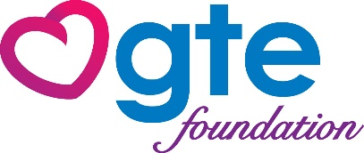
Congratulations to Polk County Adult Schools and many thanks to GTE Financial and GTE Foundation!!
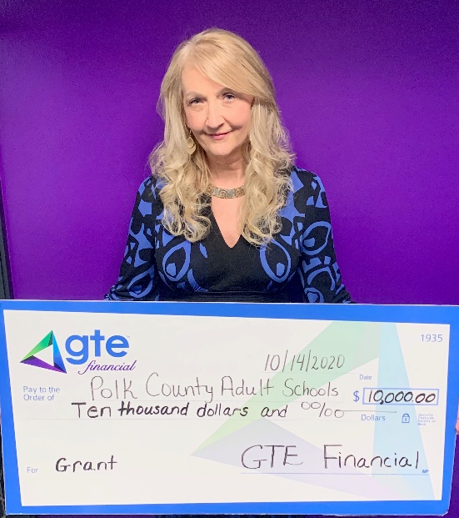
Thanks to GTE Financial and GTE Foundation, many more students will be able to attend classes. This $10,000 grant will provide funding for the $30 tuition fee for students needing financial assistance! We are so grateful for their partnership and generosity. This check was presented to the Polk County Adult Schools (PCAS) virtually by Ms. Tania Pratt at the GTE offices in Lakeland.
Over 23% of adults in Polk County read below the third grade level and many more have not completed their high school requirements. Polk County Adult Schools provide GED preparation classes to receive their State of Florida High School Diploma, and assist students with learning or improving their English reading, speaking, listening, and writing skills. The goal is to increase adult literacy skills, increase the graduation rate, and improve the workforce by encouraging these students in their educational and vocational goals. When people join the workforce, they are more likely to increase their economic situation, secure better housing and transportation, and improve their family life. This helps decrease the crime rate and poverty levels of our wonderful Polk County.
PCAS have classes on campus, day and evening, in Auburndale and Lakeland, and also have classes in Haines City, Lake Wales, Winter Haven, and soon to be in Mulberry! We have Florida licensed teachers, a school counselor who meets with each student after testing to determine their best course of action, a transition specialist who works with students upon graduating to finalize college applications and complete the FAFSA for financial aid. Serving students 16 and older, both East and West Area Adult Schools are accredited Polk County Public Schools. Testing is $20 and Tuition is $30 for the complete semester.
Thank you thank you, GTE Financial and GTE Foundation!

