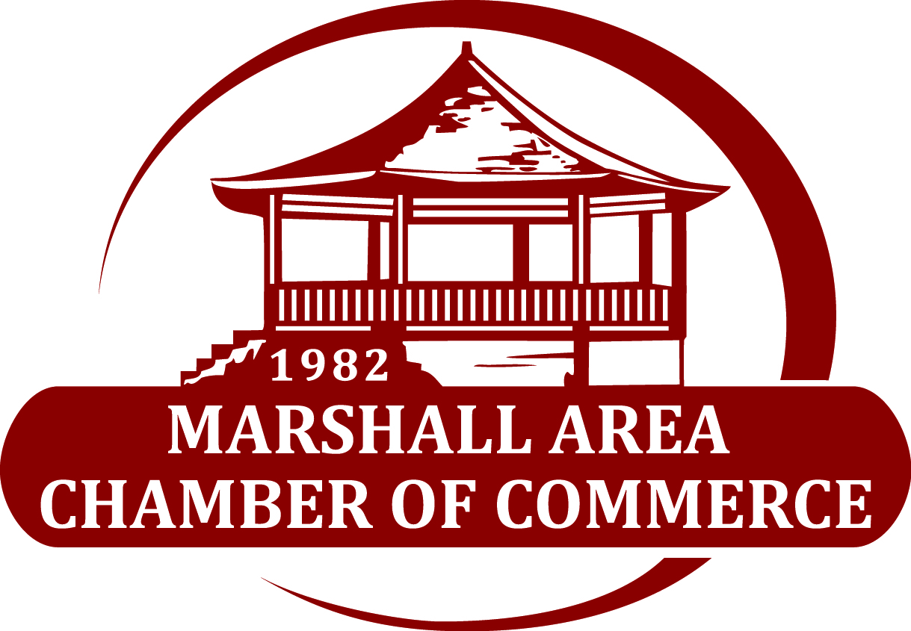

Community Service
Award Nomination Form
The Community Service award is given to a citizen of the Marshall area as recognition for his or her service which has shown exceptional dedication to the City of Marshall and its people over the course of the previous year. Worthy considerations include interest and commitment to improving the quality of life for all citizens, altruistic leadership/stewardship, consistent volunteerism, enhancement of community and overall ambassadorship. (Generally speaking, a passion for the people of and life of Marshall).

The Community Service Award makes it possible to bring public attention to those people whose deep sense of public pride compels them to give unselfishly of their time to benefit others in their community. The award may recognize long years of continues service, recent years contribution, or for service during the preceding year.

All nominations must be returned by Monday, January 16, 2023
Marshall Area Chamber of Commerce
C/O Awards Committee
708 Archer Ave | Marshall, IL 62441

*NOTE: the winner will be the parade marshal at the Autumn Fest Parade

Name of nominee: ___________________________________________________
Address of nominee: _________________________________________________
Nominated by: ______________________________________________________
Please provide a brief statement of why you are nominating this Organization:

__________________________________________________________________________________________________________________________________________________________________________________________________________________________________________________________________________________________________________________________________________________________________________________________________________________________________________________________________________________________________________________________________________________________________________________________________________________________________________________________________________________________________________________________________________________________________________________________________________________________________________________________________________________________________________________________________________________________________

Winner will be announced at the Chamber Annual Celebration, February 2, 2023.

