September is Passport Awareness Month, and we are looking forward to helping you prepare for your international travel:
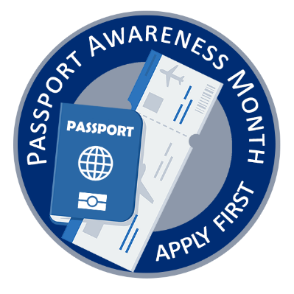
· Have a passport in hand before booking travel
· Routinely check your passport’s expiration date
· Understanding passport validity requirements (many countries require six months of validity)

Apply for your passport 6-9 months before passport expiration date or planned travel.

To better Serve you during the month of September, we will offer three after hour passport events: Fri. Sept. 13th 6p-8p; Sat. Sept. 14th 9a-12p at The Chamber 122 N. Main St. and Thurs. Sept. 26th from 6p-8p at Southern Woods Plantation.

Routine Passport: $130 for Adults (16 and older) Children $100 (0-15 years)
Expedited Passports: $190 for Adults (16 and older) & Children $160 (0-15 years)
Routine Passport Processing Times are 6-8 weeks
Expedited Passport Processing Times are 2-3 weeks

For more details Stop by or call the Worth County Clerk of Courts Office and Let’s Talk Passports: 201 N. Main St. Room #13 Sylvester, Ga (229) 776-8205
We look forward to Helping You get ready to Travel Internationally.



