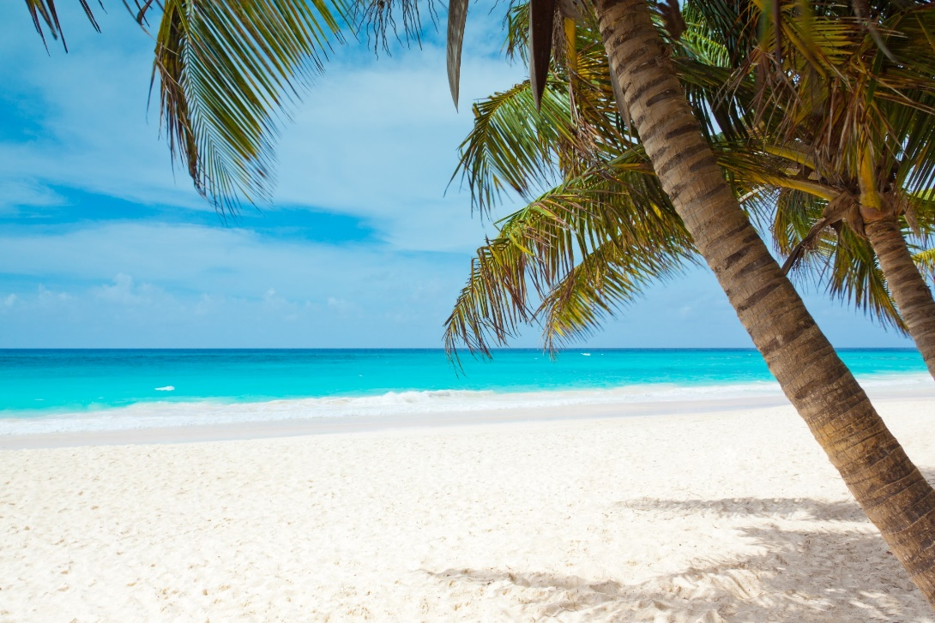
Picture yourself on a Beautiful Tropical Island……You can turn this picture into a reality.
How: Apply for your U.S. Passport at the Clerk of Court Office Mon-Fri from 8a-5pm
To Better Serve you during the Month of Sept. the Clerk’s Office will be hosting three After Hour Events.
Fri Sept 13th location: The Chamber of Commerce Building (122 N Main St. Sylvester) 6pm-8pm
Sat. Sept 14th location: The Chamber of Commerce Building (122 N Main St. Sylvester) 9am-12pm
Thurs. Sept 26th We will have a table set up at the Chamber of Commerce Annual Diamonds & Pearl Event at Southern Woods Plantation.

What you will need:
2x2 Photo (They can be made at CVS)
Birth Certificate (Certified Copy)
Photo ID
Money Order or Check (Routine $130 or $190 Expedited for application fee)
$35 cash for Processing Fee.
We will have Passport Applications available for you to complete.

Passports are Valid for 10 years

